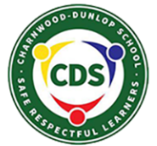
Our Statement of Philosophy

At Charnwood-Dunlop Preschool, we believe:
Families are the first and most important educators of children and that children learn best when strong partnerships are formed between families and educators. Every day in our preschool you will see families of all cultures and backgrounds:  - sharing knowledge, moments of pride and stories of home learning  - collaborating with educators  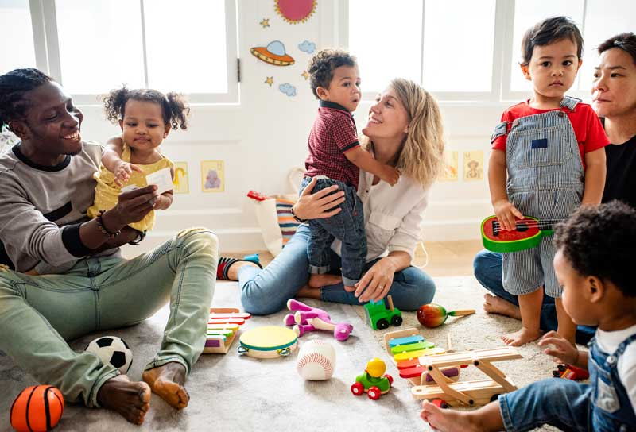  - forming secure, respectful and reciprocal relationships, connecting with each other and the Charnwood-Dunlop community  - staying and playing. | Children learn best when they have a deep connection with educators, who encourage children to inquire and take ownership of their learning. Every day in our preschool you will see educators:  - modelling just enough to show the children how and why  - listening  - questioning  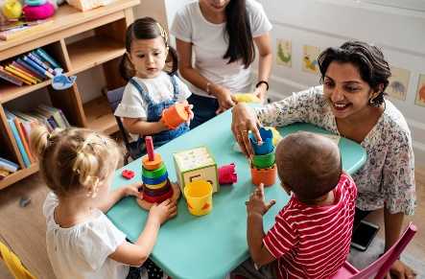  - encouraging children to take calculated risks.
Every child is unique, strong in culture and experience, and eager to learn. Every day in our preschool you will see children:  - discovering, wondering and researching  - sharing knowledge and learning together  - consolidating and extending their thinking and ideas about the world  - engaging in learning through play in rich and varied environments  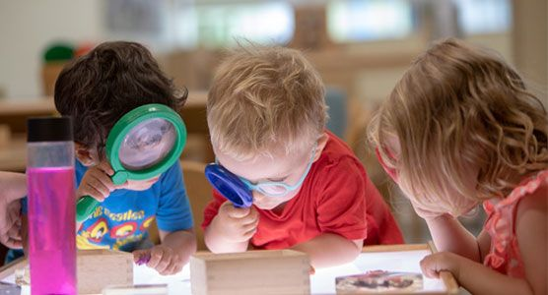  - taking calculated risks. | All children are capable learners and come with a sense of agency. Every day in our preschool you will see educators:  - teaching with intention  - co-constructing learning with opportunities to inquire, experiment and take calculated risks  - responding to children’s ideas, strengths, abilities and culture  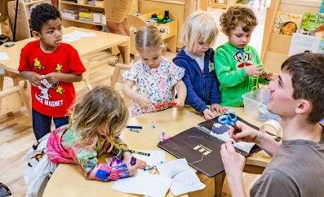  - documenting children’s learning to extend their thinking, research and understanding about the world.

Cherish your children, for they are the footprints you will leave behind.
Taylor Evans Fulks

