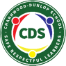
Charnwood-Dunlop School 1/2 Home learning
term 2, week 4

Dear Families,

Attached is the learning grid to enable children to continue to access their learning from home if they are not attending school face to face. Please continue to engage with online learning and post photos/videos of your child's work either onto Google Classroom or email to your child’s teacher.

Remember that play is learning too and it is vital in children's development. Playing on trampolines, riding bikes, walking, gardening and cooking together are all valuable home learning activities. We would love to see photos of these if you do them. Continue to encourage your child to read everyday to support their love of reading.

If you have any questions about your child’s learning or want to provide us with updates please email your child’s teacher.

tracy.donnellan@ed.act.edu.au grace.emery@ed.act.edu.au
thomas.mulquiney@ed.act.edu.au emily.hartley@ed.act.edu.au
merin.rayner@ed.act.edu.au lisa.williams@ed.act.edu.au
melanie.archie@ed.act.edu.au

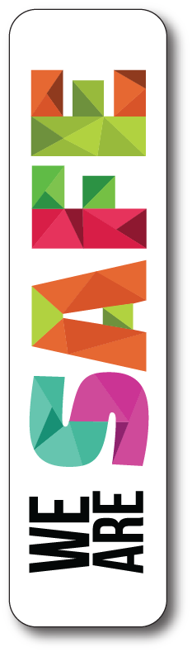  - We push our chairs in at the table  - We walk inside  - We pick up our toys in our room | - We say please and thank you  - We are quite when people are sleeping | - We try our best  - We practise our reading every day
Year 1/2 English and Maths Home Learning Grid Week 4
 | Monday | Tuesday | Wednesday | Thursday | Friday
English | Reading:  By yourself  Hot reads- enjoyment for reading  Watch a story from Story Box Library. Use the link below.  https://storyboxlibrary.com.au/login  Username: Charnwood-Dunlop School  Password: CDS2615  Writing  By Yourself  Write a book review from a book you’ve read or listened to on Story Box Library.  Include the following:  - Title  - Author  - Characters  - Main Ideas  - What you most enjoyed about the text  - Give it a star rating out of 5  - Write this in your take home reading book  Phonics  By yourself  Review of /bl/, /gl/, /pl/  Add at least three new words to your blend word lists?  Can you find some more words where the blend is in the middle of the word? | Reading:  By yourself  Hot reads- enjoyment for reading  Watch a story from Story Box Library. Use the link below.  https://storyboxlibrary.com.au/login  Username: Charnwood-Dunlop School  Password: CDS2615  Writing  By Yourself  Watch the story ‘The Gruffalo’.  https://www.youtube.com/watch?v=s8sUPpPc8Ws  Complete a story map of ‘The Gruffalo’. Use the link below as a guide to help you.  https://www.education.com/worksheet/article/story-roadmap/  Phonics  By yourself  Write 5 complex sentences (using ‘and’ or ‘because’) using a /bl/, /gl/ or /pl/ word.  Eg. Joe played tennis after Glenice watched TV. | Reading:  By yourself  Hot reads- enjoyment for reading  Watch a story from Story Box Library. Use the link below.  https://storyboxlibrary.com.au/login  Username: Charnwood-Dunlop School  Password: CDS2615  Writing  By Yourself  HOT WRITE  Write about a topic or something that interests you.  Remember to include the date at the top of the page, use capital letters and full stops and an illustration. | Reading:  By yourself  Hot reads- enjoyment for reading  Watch a story from Story Box Library. Use the link below.  https://storyboxlibrary.com.au/login  Username: Charnwood-Dunlop School  Password: CDS2615  Writing  By Yourself  Write a letter to your favourite character from a book or movie. Tell the character about yourself and what you like about them.  High Frequency Words By yourself  play, little, said, then, can, living, them, were, children, very, saw, and, because  1) Use the high frequency words above to make your own memory game. Write each word on two squares of paper and then turn them face down and match the words.  2)Find these words in books and practise writing them in your workbook. | Reading:  By yourself  Hot reads- enjoyment for reading  Watch a story from Story Box Library. Use the link below.  https://storyboxlibrary.com.au/login  Username: Charnwood-Dunlop School  Password: CDS2615  Writing  By Yourself  Pick your favourite book and draw the key events in order.  What is the key message of the story?  Use the link below as a guide to help you.  http://www.tlsbooks.com/pdf/drawastorysequencing1234.pdf  High Frequency Words  By yourself  Word Jumble of the Day. How many words can you find?  https://drive.google.com/open?id=1OIpYPniJwhctNUo9Q3yeKpqz1NAwshaJ9D9RpXBD8Bo
Maths | Number warm up:  By yourself  Counting Patterns  Set a timer for 1 minute and write down a number pattern.  E.g 2, 4, 6, 8, 10…  Do this a few times with different patterns.  Learning experience:  With an adult  Choose 3 numbers from your number cards pile and make the largest number you can. What is the smallest number you can make?  Think about the way you learn maths.  Write a comment on your Google Classroom with some PBL expectations you have for maths. | Number warm up:  With an adult  Friends of 10  In 1 minute how many friends of 10 can you write?  Eg. 9+1, 1+9  Learning experience:  With an adult  Colour in different skip counting patterns using the online hundreds chart below.  Orange: Skip count by 2  Pink: Skip count by 3  Yellow: Skip count by 5  Blue: Skip count by 10  https://www.mathplayground.com/interactive_hundreds_chart.html  Rolling to 100  Use a 100s chart to play the Rolling to 100 game.  1.Find a partner (or roll by yourself). Each person has a different colour.  2. Take turns rolling the dice (use the link above if you don’t have a dice).  3. Count that many squares and mark the box with an x.  4. First person to get to 100 wins.  https://www.superteacherworksheets.com/hundredschart/hundreds-chart-filled_WNRTB.pdf?up=1466611200  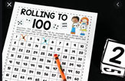 | Number warm up:  With an adult  Skip Counting Game  Roll one dice and then skip count by 2s, 5s, 10s from the number rolled.  Eg. Skip Counting by 2  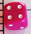 6 8 10 12  Use a hundreds chart to help you.  If you don't have a dice you can use the interactive spin wheel using the link below.  https://wordwall.net/resource/49009/maths/random-number-wheel-1-10  Learning experience:  By yourself  I have number cards and I dropped them. I need to pick them up in order…. How can I do this?  Watch Miss D’s video.  https://drive.google.com/file/d/1U7DO3MBBOg4Dimw7L2T-kLs6UXQDtWjf/view?usp=sharing  Record all the different ways you could order the cards. | Number warm up:  By yourself  Choose a starting number and count backwards by 1s or 2s as far as you can in 1 minute.  You could start at 115.  Learning experience:  With an adult  Who am I?  Write clues about a number and ask someone to guess the number..  e.g.  -I am an even number  -I have 1 ten  -I have 2 ones  -The number that comes before is 11  Write clues for 2 odd numbers and 2 even numbers. | Number warm up:  By yourself  Starting at 10, how far can you count up to in 1 minute?  Try it again and see if you can beat your last attempt.  Learning experience:  With an adult  Calendar maths  Create a calendar for the month of May. Include these important dates:  10th - Mother’s Day  26th - Sorry Day  How many days are in May?  How many weekends are there?  What day of the week was the 8th May?  Do any of your friends or family have a birthday in May? If so, write their name on your calendar. Use the link below to help.  https://docs.google.com/document/d/1xIajL4R-ZhW6nTdZoDLoESf4ZbelKnlRSlaFyZELY5I/edit#
Inquiry Activities | Movement  With an adult  - Go for a bike ride  - Go for a walk  - Practise throwing and catching with a ball or pair of socks | Specialist Work  With an adult  Complete an activity from your specialist teacher in the Google Classroom.  STEAM (1/2MR, 1/2TM and 1/2 GE)  Spanish (1/2 TD and 1/2EM) | SEL  By yourself  Complete a SEL activity from your specialist teacher in the Google Classroom. | Art  With an adult  Ken Done is a famous Australian artist. Watch the video below.  https://www.youtube.com/watch?v=30u8QTAbuHA  The picture below is titled ‘Birds of Paradise’. Discuss all the different ways Ken Done used texture in his painting. Eg. Thin/thick lines, wavy/straight lines, single & multiple lines.  Discuss the colours that were used. Refer to colour wheel. Use the link below as a guide to help you. https://uxplanet.org/analogous-colors-and-color-wheel-609a05b5b90e | Can I play?  With an adult  Have a look at the games you have at home. Play a board game or create your own game like Snakes and Ladders.
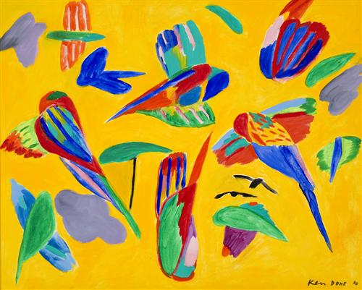
Inquiry Online Resources

Living Things Song: https://www.youtube.com/watch?v=tzN299RpJHA
Living Things Video: https://www.youtube.com/watch?v=Gy60BqCnTG4
Living vs non-living video & activities: https://www.generationgenius.com/videolessons/living-vs-non-living-things-video-for-kids/#lesson_materials
Follow-Along Drawing/Craft Channel: https://www.youtube.com/user/ArtforKidsHub
Playschool Story Time (read alouds) https://iview.abc.net.au/collection/2392
Story Dramatisations (30 minutes approx) https://iview.abc.net.au/collection/407
Andy’s Safari Adventure (14 minutes each about animals!) https://iview.abc.net.au/show/andy-s-safari-adventures
Kid Friendly Info About COVID-19 https://www.abc.net.au/btn/newsbreak/btn-newsbreak-20200323/12082020
Aboriginal Star Mapping https://www.abc.net.au/btn/classroom/aboriginal-astronomy/10523908
Aborignal Place Names: https://www.abc.net.au/btn/classroom/indigenous-place-names/11164046

Maths Resources

Maths - Place Value Party (choose how big numbers will be first) https://www.mathplayground.com/place_value_party.html
Maths - Place Value Basketball (choose how big numbers will be first) https://www.topmarks.co.uk/learning-to-count/place-value-basketball
Oxford Owl Maths Videos (watch the early maths skills ones) https://www.youtube.com/playlist?list=PLB5TN0ac12P_p1yZu7bieuGfK8X5pptza
Money Games (choose Australian coins and the task first) https://www.topmarks.co.uk/money/coins-game

