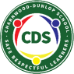
Charnwood-Dunlop School Home Learning
“You can find magic wherever you look.
Sit back and relax, all you need is a book.” Dr Seuss.

Term 2, Week 2

Dear Families,

Welcome to Week 2! Here is the learning grid to enable children to continue to access their learning from home. Activities will be posted on Seesaw to support this learning. Please continue to post messages and photos of your work on Seesaw. We appreciate all you are doing and are here if you need us.

Please remember to tap into Seesaw every morning before 11:00 am, as this is how we are marking the roll. We are legally obliged to submit the roll every day to the Education Directorate.

Continue to provide opportunities for your child to undertake fine motor activities such as drawing, cutting and using playdough. Reading is an everyday activity. Perhaps you could build a reading fort using pillows and blankets over a table to provide a quiet reading area. Books should be explored and discussed. Encourage your child to ask questions during reading, such as predicting what might happen in the story or at the end of the story. It is good to comment on the story as well, especially if your child can make a connection between what is happening in the book to an experience they have had. The weekly words can be searched for in books, made into word cards and written in sentences. Children are encouraged to complete tasks in their workbook to enable them to track their progress and celebrate their success as learners.

You may like to schedule your child’s day following their regular time table for example:
- 20-30 minutes of reading
- 20-30 minutes of writing
- 20-30 minutes of physical movement
- 20-30 minutes maths tasks
- 20-30 minutes of physical movement
- Encourage creative at home tasks

Please don’t hesitate to contact us and we will get back to you as soon as we can.
Eliza.Savage@ed.act.edu.au
Gayle.Dyer@ed.act.edu.au
Helen.Hardy@ed.act.edu.au
Annie.Wild@ed.act.edu.au

Kindergarten Home Learning Grid Week 2
Navigating the grid
- Remember to keep the activities short (less than 30 minutes).
- If it is becoming stressful, then stop, take a break and come back to the task when everyone is feeling refreshed.
- Balance academic tasks, connections at home and life skills.

Sample PBL expectations:
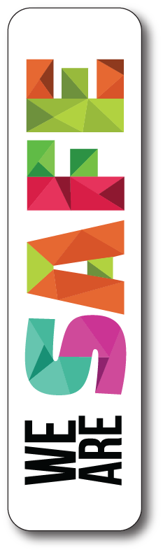
- We visit safe sites online  - We use equipment responsibly | - We take care of our property  - We share our belongings with family | - We have a go  - We try to do our best work

English  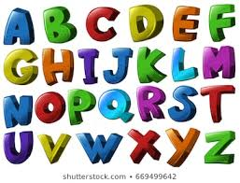 | Reading strategy  Predicting and questioning  Look at the cover - what do you think the story is about?  How do you think the story will end?  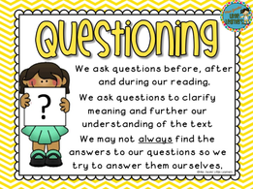 | Phonics in context  Letter sound of the week  /h/  Look at your favourite story book. How many words beginning with ‘h’ can you find? Copy them into your workbook.  Phonics experience: make a hamburger, a ham sandwich, or try hopping on one foot.  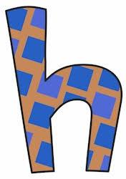 | High Frequency words  Look in your picture books at home. Can you find these words?  he, his, was, for, on, as, at, that, so,  Make the frequent words using letter cards.  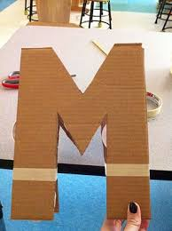 | The adventure of my favorite toy.  Have a go at writing your own story. You may like to draw a picture first, then have a go at writing the letters and words about the things that are happening in your picture.
Maths  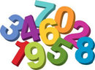 | Numbers 1-10  Make cards using recycled cardboard boxes - write the numbers in words - one - ten on each card.  Match your number cards one - ten to items around the house.  See Seesaw video of the teacher’s demonstration | Seesaw Activity  Make a number book for the numbers 1 to 10. Be creative. Use the same format for each number and just change the words, e.g. I see one hungry hippo. Write the numeral 1, the word one, and draw a picture that matches the sentence.  Then the next page is for 2, e.g. I see two hairy wombats | Seesaw Activity  Continue making your number book. Write the numeral 1, the word one and add colour pictures to match each number. | We hope you have now finished your number book for the numbers 1 to 10. Remember to post a video of you reading your book to us.
Inquiry | How does the weather change?  This week we are making a weather book that shows the four seasons. We will start with summer.  What activities do you do in summer? What clothes do you wear? What does the environment look like? | How does the weather change?  Autumn  Continue working on your weather book. Today’s page is about autumn. Remember you can label your pictures or write a sentence or two about them. | How does the weather change?  Winter  Continue making your weather book - showing winter. | How does the weather change?  Spring  Complete your weather book - showing spring.  When your book is finished make a video of yourself reading your book and post it to Seesaw.
Health, Community and & PE  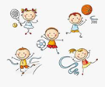 | Social and Emotional Learning  Watch - Alfie’s Big Wish on Story Box Library  When Alfie made a wish and found a friend he had heaps of fun.  Draw a picture of you playing with a friend and write a sentence to tell us what you are doing.  Don’t forget to take a photo and put it up on Seesaw so that we can see all of your great ideas and work. |  | Walk  Ask an adult to join you on a walk. How many trees can you count on your walk and are they the same? Take some pictures if you can and upload them to seesaw.

Web based Curriculum Links

Literacy -

ABC mouse / h / https://www.youtube.com/watch?v=kfxm1I7L07I

Jack Hartmann / h / - https://www.youtube.com/watch?v=PUI5-AphjMg&t=18s

Writing - https://www.youtube.com/watch?v=vo2xZskgdP4

Reading - https://www.youtube.com/watch?v=LiTWw87v_w4

Maths -

Numbers and words - https://www.youtube.com/watch?v=HG361wJyDY0

Calendar - https://www.youtube.com/watch?v=wkRkzn74Q9U

Inquiry -

Seasons - https://www.youtube.com/watch?v=_6cG913j6kc

Autumn - https://www.youtube.com/watch?v=dKjUPqbt8DU

Calendar - https://www.youtube.com/watch?v=wkRkzn74Q9U

Getting dressed with Lecky - http://www.crickweb.co.uk/Early-Years.html

Physical activity -

Movement break - https://www.youtube.com/watch?v=388Q44ReOWE

Animal song - https://www.youtube.com/watch?v=wCfWmlnJl-A

