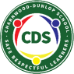
Charnwood-Dunlop School 1/2 Home learning
term 2, week 2

Dear Families,

Navigating the grid:
- We recommend that as a family you set your own PBL (Positive Behaviours for Learning) expectations for your child’s home learning. This will assist you to avoid misunderstandings and to set expectations and routines.
- We have included below some PBL expectations that you may wish to use with your child throughout the week.
- Please remember to keep the activities short (less than 30 minutes). If it is becoming stressful, then stop, take a break and come back to the task when everyone is feeling refreshed.

English and Maths Grid:
- This term we have created a weekly timetable as your teachers will be uploading additional information and videos on Google Classroom to support your child’s learning. These uploads will occur in Google Classroom to support the days learning experiences that are displayed in the grid below.
- Starting this week, teachers have added a bonus section underneath each learning task for English and Maths. This will allow for you to continue supporting your child if they require additional work. These tasks are optional.
- Your child may choose to complete tasks in their work books or online. If in a workbook you may choose to take a picture and post it online to Google Classroom or send your teacher an email.
- The weekly tasks are divided into the following categories
- complete independently (By myself)
- need help from a sibling or to work with a friend (via the phone or computer) (Sibling or friend)
- need help from an adult (Adult)
Inquiry Epraise Activities:
- Your child will also be rewarded an Epraise point for being an ‘Independent Learner’ if they complete the ‘Bonus tasks’
- You may wish to complete 1-2 activities from the grid for each day. There is no expectation that your child has to complete all activities throughout the week.
- Balance academic tasks and life skills.

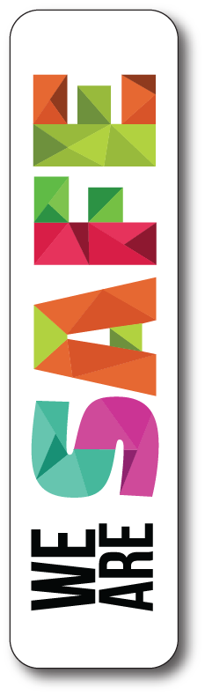  - We wash our hands with soap frequently  - We follow instructions | 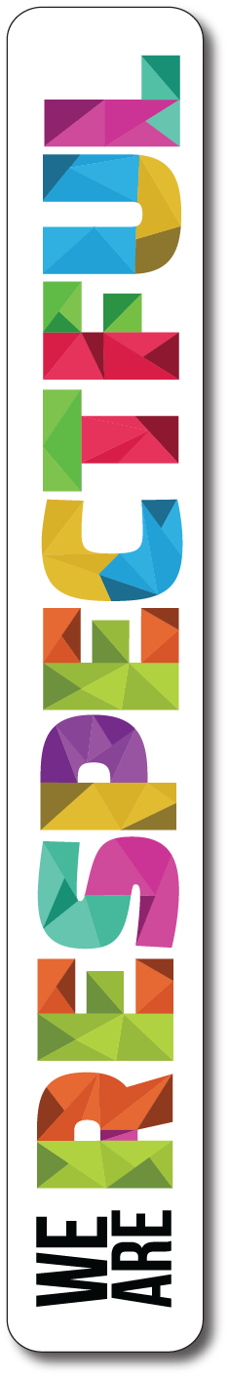  - We use kind words  - We put our things away | 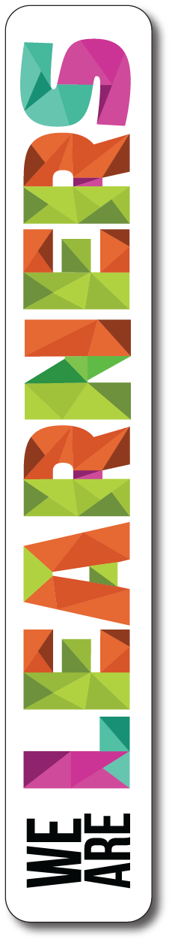  - We try our best  - We ask questions to find out something new

If you have any questions about your child’s learning or want to provide us with updates please email your child’s teacher.

tracy.donnellan@ed.act.edu.au grace.emery@ed.act.edu.au
thomas.mulquiney@ed.act.edu.au emily.hartley@ed.act.edu.au
merin.rayner@ed.act.edu.au lisa.williams@ed.act.edu.au
melanie.archie@ed.act.edu.au

Year 1/2 English and Maths Home Learning Grid Week 2
 | Monday | Tuesday | Wednesday | Thursday | Friday
English | Reading strategy:  Main ideas in texts  By yourself:  Watch morning hot reads on google classroom and talk about the book to a family member.  https://drive.google.com/open?id=1n2AfnWXI-yh-EkKSH8fHUAMKEo64MT4r  Writing  By yourself:  After listening to the story this morning draw a picture of your friends. Then write about what friendship means to you.  Phonics in context  By yourself:  Watch the /bl/ blend video below.  https://www.youtube.com/watch?v=LzZe2qmk8sk  https://drive.google.com/open?id=1vxG55Nmbxa_1c_jJu8yHS4p8NFJMqSga  /bl/ Hunt  In your reading, write all the words that have the /bl/ sound at the beginning of the word.  Can you find words with the /bl/ sound in the middle or end of the word?  Bonus Activity  What achievement are you most proud of so far? Type your response on a google doc or write it down. Write more than two sentences. | Reading strategy:  Main ideas in texts  By yourself:  Watch morning hot reads on google classroom and talk about the main ideas of the book to a family member.  https://drive.google.com/open?id=1h18zZTBjGpi1d-SJoetCcQAt2MZpeFbR  Writing  By yourself:  Watch Mrs Emery’s video of writing simple sentences.  https://drive.google.com/open?id=1l3lPg68lylKK16K23uYI5sdLmBGWkoAN  Phonics in context  By yourself:  Write sentences using /bl/ words.  With an adult:  Write a story using as many /bl/ words as you can.  Underline all the /bl/ words.  Bonus Activity  Using simple sentences create your own Elephant and Piggie book. You may like to include:  - Front cover  - Back cover  - Author/illustrator  - Detailed illustrations | Reading strategy:  Main ideas in texts  By yourself:  Watch morning hot reads on google classroom and talk about the main ideas of the book to a family member. Draw main ideas.  https://drive.google.com/open?id=1rCrI9PrMHW_B5DL1WbE7Xf7VMAJksS69  Writing  By yourself:  Hot Writes  Write about any topic or thing you want.  Make sure you have the date at the top of your page and are using capital letters and full stops.  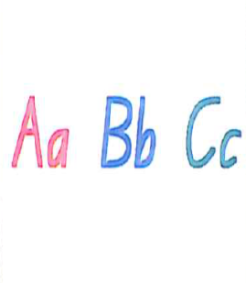  Bonus Activity  I can edit my writing and write two more sentences. Put a line under any words that you are unsure of how to spell. Use a dictionary or google to help with spelling.  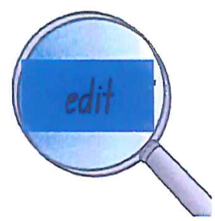 | Reading strategy:  Main ideas in texts  By yourself:  Watch morning hot reads on google classroom and complete the quiz.  https://drive.google.com/open?id=1e2wFY1cA-m8YYl_j7PjWFNkwzFeUxmoE  Writing  By yourself:  Write silly sentences using the /bl/ sound in your writing book.  Watch Miss Rayner’s story below.  https://drive.google.com/open?id=1FBZ-ZZbVg2g0o-XOo1fsIelmEah9DPUq  High frequency words  By yourself:  Look in your picture books at home. Can you find these words...  them, were, children, very, saw  and write them down?  You could write them in your take home book or with chalk on the ground.  Bonus Activity  Word Jumble of the Day.  Can you find the bonus word? | Reading strategy:  Main ideas in texts  By yourself:  Watch morning hot reads on google classroom and complete the quiz.  https://drive.google.com/open?id=1bAyCitBFuu0uarPKDQ4-dqrACAWzZDKv  Writing  By yourself:  Watch Ms Mel’s read aloud of ‘My Two Blankets’.  https://drive.google.com/open?id=1N8pecs6Ph7tBNs4rbRcg6FiunXQEzvrd  Draw and design your own blanket. Include pictures or items that you like or find comforting.  Will it have patterns? What colours will you use?  High frequency words  By yourself/with a sibling:  Use the high frequency words from last week and this week and make your own memory game. Write each word on two squares of paper and then turn them face down and match the words.  play, little, said, then, can, living, them, were, children, very, saw  Bonus Activity  Write a review of the story “My Two Blankets” and give reasons why you liked or did not like the story. Write more than two sentences.
Maths  Focus: Shapes | With a sibling or Adult:  Watch the shapes video below.  https://www.youtube.com/watch?v=beTDz9HSNOM  Draw and label as many 2D shapes as you can. Write some clues for them e.g.  - I have four sides that are all the same length.  - I also look like a sandwich.  - What shape am I?  Bonus Activity  Choose one of the following 2D shapes:  - Kite  - Rhombus  - Octagon  and create a poster. Include the following information:  - Hand drawing of the shape  - Characteristics:  - How many edges does it have?  - Does your shape have curved or straight lines? If the lines are straight are they equal or parallel?  - Where would you find this shape in the environment? | With a sibling or adult:  Take photos of different shapes around your house. Upload these photos into your google classroom. Tally how many of each shape you find.  Bonus Activity  Code breaker  Write your name using only 2D shapes. Using these shapes make your own alphabet and write a secret message for someone in your house to work out.  Watch Miss Rayner’s video.  https://drive.google.com/file/d/1rsQDaYcicxZe9hr0ZcpqqIMxrc-qCaGu/view?usp=sharing | By yourself:  Mr Squiggle  On a blank page, draw a picture that includes:  7 triangles  6 squares  2 circles  3 rectangles  What picture can you make?  Set your family the same challenge.  Bonus Activity  Create an art piece using 2D shapes such as:  - Hexagon  - Octagon  - Rhombus  - Triangle  - Circle  - Square  - Rectangle  Make sure the shapes overlap each other. | With a sibling or adult:  Shape Drawings  Watch the video below of Miss D and Miss R.  https://drive.google.com/open?id=1Mq2jPqHDyWnbeodj86RaOdyiyssPm78u  Sit back to back to create an image with a partner by telling them the shapes and where to draw them. You are not allowed to look at each other's drawings until the end.  Bonus Activity  After watching the video and drawing your picture, write down the steps you used. Give these steps to another family member to follow and draw a picture. | With a sibling or adult:  Celebrity Shapes  - What shape am I? -  This game is like Celebrity Heads. Write down different shapes and ask questions to work out which shape you are.  Play the game with other members of your family.  Bonus Activity  Draw a shape - any shape that you like. Then change it into something. Maybe your shape will turn into a hat or boat?

Inquiry Epraise activities
Lifestyle | Keep a track of the trees and their changing autumnal colours. Draw this over a week or two, to see the changes and the leaves dropping. As a home helper can you rake up the leaves? | Make your own coins and notes and set up a shop. Make some price tags and place them on some items in your home. You may wish to use some crafts you have created or grocery items.  Play a game with your siblings or an adult where you are the shopkeeper and they are the customer. Reverse the roles.
The Arts | Stick Drummer  Find two sticks that aren’t too big to be drumsticks.  Tap them on different surfaces and notice the sounds different materials make.  Can you make a beat or pattern and teach it to someone?  Can you write down (notate) your beat or pattern? | Book Actor  Act out one of your books from hot reads. You might need to use some toys to help!
Living Things | Research your favourite living thing and think about the questions below.  How have they changed over time?  What type of environment does your living thing live in? | Make a list of items/things that the animal you researched needs to survive.
Movement and Health | Animal circuit  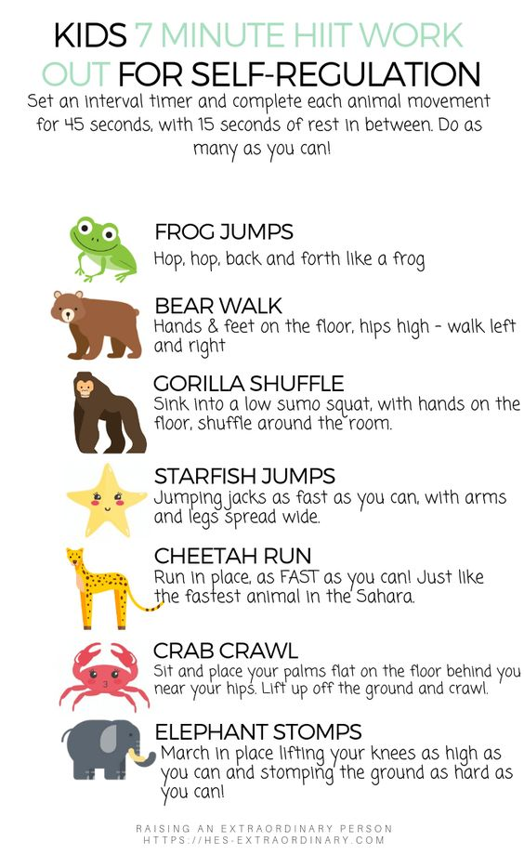 | Shooting hoops  Using a pair of socks and a laundry basket, how far can you throw the socks and land them in the basket?  Challenge - How many times can you land them in the basket in 1 minute?
Fine Motor | Cutting  Trace your hand and cut it out. Make sure you cut as close to the lines as possible. | Build a Structure  Build a structure from materials at your house.  Use lego, cardboard, sticks, or anything you can find.

Please visit the websites below to further support learning.

Author: Freya Blackwood - My two blankets
https://www.freyablackwood.com.au/my-two-blankets-1/ihzoe0tv7kumnh6o2z4l2ye3fg0dhj
Anthony Browne - Shape game
http://www.anthonybrownebooks.com/the-shape-game
ABC splash - buttons and shapes
https://education.abc.net.au/home#!/media/2450967/buttons-and-shapes
ABC iview - big block sing song - shapes
https://iview.abc.net.au/show/big-block-singsong
ABC iview - painting mirrored shapes
https://iview.abc.net.au/show/create/series/0/video/CK1617V015S00
ABC iview - painting abstract art with shapes
https://iview.abc.net.au/show/create/series/0/video/CK1617V011S00

