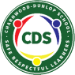
Charnwood-Dunlop School
5/6 Term 2 Week Home Learning

This term, 5/6 will continue learning about states of matter and will finish up with their natural disasters inquiry unit. We will then move into our Civics and Citizenship inquiry unit for the remainder of term 2.
In the timetable below there are tasks related to these topics along with literacy and math lessons to revise and extend on concepts learnt at school.

Navigating the timetable:
- We recommend that as a family you set your own PBL (positive behaviours for learning) expectations for your child’s home learning. This will assist you to avoid misunderstandings and to set expectations and routines.
- We have included below some PBL expectations that you may wish to use with your child throughout the week.
- Please remember to keep the activities short (approx 30 minutes). If it is becoming stressful, then stop, take a break and come back to the task when everyone is feeling refreshed.
- The timetable is a suggested schedule only. This can be adapted to meet the needs of your family, however some lessons may not be available until the set day. There is no expectation that your child has to complete all activities throughout the week, however the more your child participates the more they will get out of online learning.
- Try to balance academic tasks and life skills.
- Your mental and physical wellbeing are just as important as your learning as we navigate these uncharted waters.
- The majority of the below tasks will be completed in google classroom. If you can not access this, you will be able to access some of these tasks/worksheets from the Charnwood-Dunlop School website under home learning.

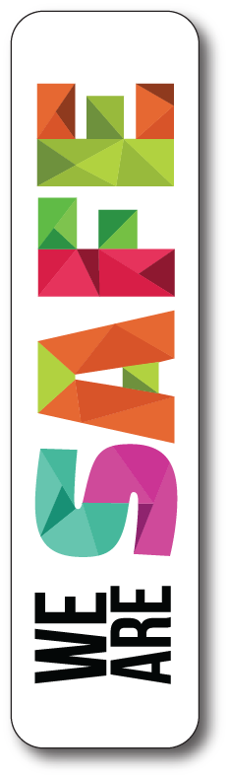  - We wash our hands with soap frequently  - We follow instructions  - We do not access content on the internet without parents or teachers permission | 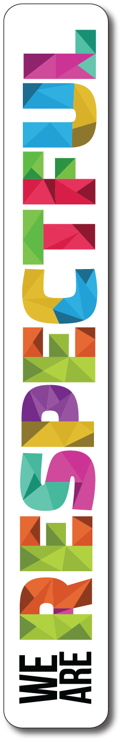  - We use kind words  - We put our things way  - We wait our turn when using google meets | 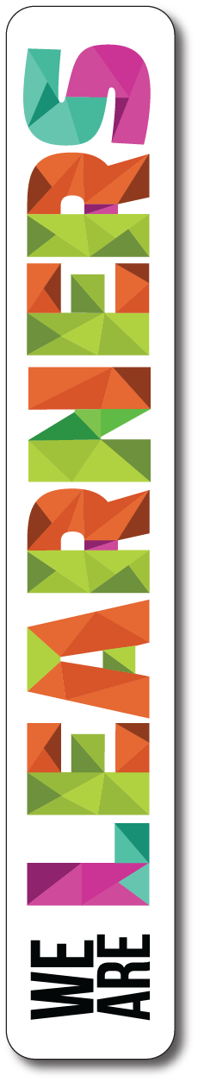  - We try our best  - We ask questions to find out something new  - We use our chromes appropriately

If you have any questions about your child’s learning or want to provide us with updates please email your child’s teacher.

 | Monday | Tuesday | Wednesday | Thursday | Friday
Morning | Hot Reads | Hot Reads | Hot Reads | Hot Reads | Hot Writes
 | Reading Comprehension  Audio book Chapter 12 - Please refer to google classroom for instructions | Spelling and Grammar  Apostrophes showing possession | Speech Writing  What does a good speech sound like?  10:30 Simultaneous Reading Time | Reading Comprehension  Audio book Chapter 13 - Please refer to google classroom for instructions | National Geographic  Continued from last weeks work  Let’s take a trip around the world together. See google classroom for details -
 | Spelling and Grammar  then or than | SEL / PBL  See activity from Mrs Middleton in her google classrooms. If you haven’t joined yet, the Classroom code is  kextxrv | Spelling and Grammar  your or you’re | Catch up  This time has been allocated for you to finish off and catch up on any work that you have missed this term in preparation for returning to the classroom next week.
Take a break!!!
Middle | Daily fitness and Brain Buster Challenge  Take a look into your weekly challenge book for this week's fitness challenges and brain buster. Don’t forget to upload a photo into the answer section of you doing fitness and make sure to put your challenge answers in to earn epraise points and prizes!
 | Maths  Angles - lines, intervals and rays | Release  See activity from your release teacher in their google classrooms | Catch up  This time has been allocated for you to finish off and catch up on any work that you have missed this term in preparation for returning to the classroom next week.  Priority is in this order  - Persuasive letter  - Persuasive Speech  - Maths  - Spelling / grammar  - Reading  - Science  - National Geographic  - Remote learning reflection | Maths  Angles - types of angles | Maths  Prodigy - Have some fun practising your skills
Take a break!!!
Afternoon | Reflection  Check google classroom for details  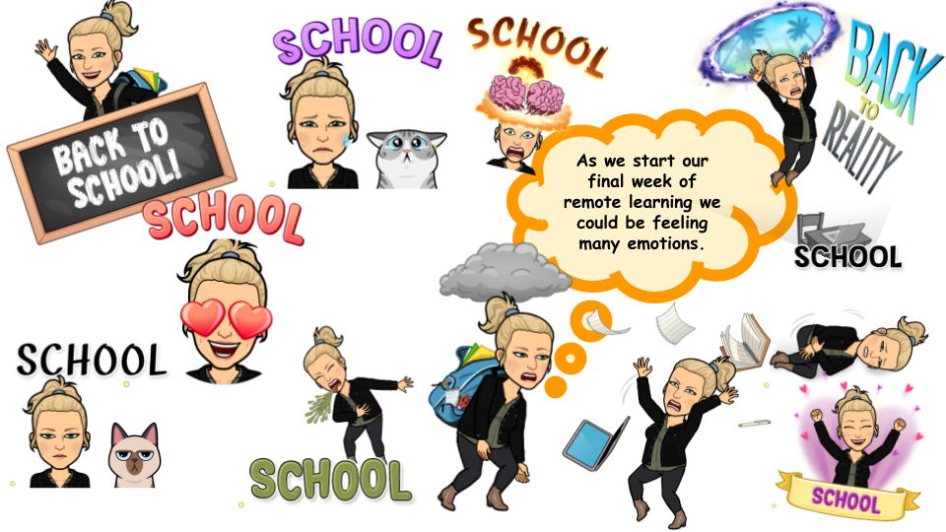 | Release  See activity from your release teacher in their google classrooms | Science  What happens when we force a liquid and a solid to mix??? | Health  Let’s look at our Lungs  See activity in google classroom. | Catch up  This time has been allocated for you to finish off and catch up on any work that you have missed this term in preparation for returning to the classroom next week.  Priority is in this order  - Persuasive letter  - Persuasive Speech  - Maths  - Spelling / grammar  - Reading  - Science  - National Geographic  - Remote learning reflection

