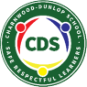
Charnwood-Dunlop School 1/2 Home learning
term 2, week 3

Dear Families,

Welcome to week 3!

Attached is the learning grid to enable children to continue to access their learning from home. The year 1/2 teachers will be modelling lessons on Google Classroom to support your child’s learning. Alternatively you can also access these from the learning grid below. Please continue to engage with online learning and post photos/videos of your child's work either onto Google Classroom or to send to your child’s teacher.

Remember that play is learning too and it is vital in children's development. Playing on trampolines, riding bikes, walking, gardening and cooking together are all valuable home learning activities. We would love to see photos of these if you do them. Continue to encourage your child to read everyday to support their love of reading.

We look forward to seeing you all the wonderful home learning experiences this week and we can’t wait to see you all soon. If you have any questions about your child’s learning or want to provide us with updates please email your child’s teacher.

tracy.donnellan@ed.act.edu.au grace.emery@ed.act.edu.au
thomas.mulquiney@ed.act.edu.au emily.hartley@ed.act.edu.au
merin.rayner@ed.act.edu.au lisa.williams@ed.act.edu.au
melanie.archie@ed.act.edu.au

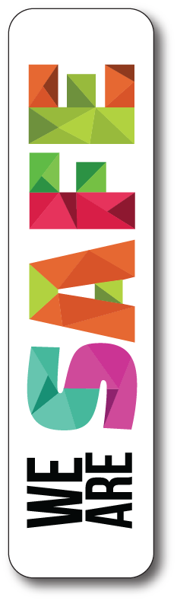  - We push our chairs in at the table  - We walk inside  - We pick up our toys in our room | - We say please and thank you  - We are quite when people are sleeping | 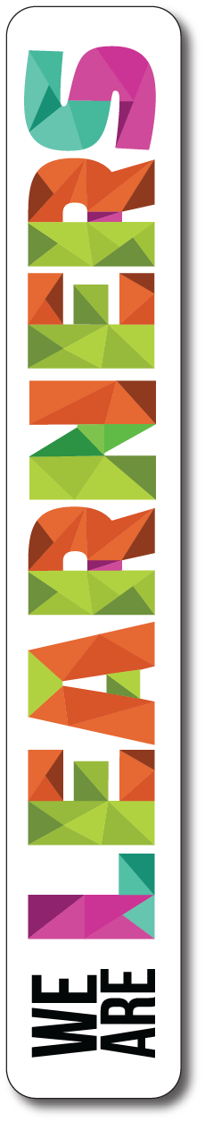  - We try our best  - We practise our reading every day

Year 1/2 English and Maths Home Learning Grid Week 3

 | Monday | Tuesday | Wednesday | Thursday | Friday
English | Reading: By yourself  Learning intention:  Hot reads- enjoyment for reading  Watch Mr Tom’s morning hot reads about Kangaroos  https://drive.google.com/file/d/1L-xzygY0i3YSN5sY7M-52Ygs9kRTJN5R/view?usp=sharing  Writing: With help adult  Learning intention:  Pre knowledge about facts and opinions  Watch Ms Emery explaining how to complete a fact sort. Complete the fact sort on Google Classroom.  https://drive.google.com/open?id=1XHiYwUoHjCFS_bgzY-nVbwVVJIjNgNy2  Phonics in context:  By Myself  Learning intention:  I can hear and write words that have the /gl/ sound.  - Find words in your books with the /gl/ sound and write them down  I can write 5 sentences with a /gl/ word in each.  Listen to the short clip about the /gl/ sound  https://www.youtube.com/watch?v=gRbKtRO9ONk | Reading: By yourself  Learning intention:  I can use the reading on strategy  Watch Miss Emily’s morning hot reads and practise using the reading on strategy.  https://drive.google.com/file/d/1OoB28A2BBMNXDwyUuMk8lW_B21s-TMTo/view  Writing: With help adult  Learning intention:  I can write facts.  Can you write some facts? It can be about any topic of your choice.  Watch Mr Tom’s video explaining how to write facts.  https://drive.google.com/open?id=14K_rwd3xH47aDv4Pklmij5bc2k3yzhh2  Phonics in context:  By Myself:  Learning intention:  I can design and draw a glass bottle that would ‘catch your eye’, like the blue strange bottle caught Ah Kee’s eye.  Watch Mrs Emery read aloud Ah Kee and the Glass Bottle. This is a long story, make sure you have time to listen.  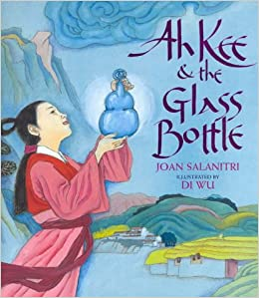  https://drive.google.com/open?id=1iAaZdmODib0J8rWLKuOXkdkUjIWWIDGC  Bonus Activity:  Write a message to put inside the bottle telling someone about yourself and why you like it. | Reading: By yourself  Learning intention:  Hot reads - enjoyment for reading  Listen to Miss D’s video of a story about what children see in the Northern Territory  https://drive.google.com/file/d/1_5pLLfzT3uAnWkyUAx8f7wr6b_A_vYqB/view?usp=sharing  Writing: By yourself  Learning intention:  Hot writes by yourself  Write about anything you like.  Remember to include the date at the top of the page and Capital letters and full stops. | Reading: By yourself  Learning intention:  I can use the reading on strategy  Watch Miss Emily’s morning hot reads and practise using the reading on strategy.  https://drive.google.com/file/d/1b28OqPtybkh96IYyUrmO2yHjpkMPy9oy/view  Writing: With help adult  Learning intention: What is the difference between a fact and an opinion?  Watch Ms Mel’s video below.  https://drive.google.com/open?id=1RctOQ8f8GGLzMcuPbujbUNLeQq0WndhV  Write three facts and three opinions about one of the below topics:  - Yourself  - Favourite food  - Family member  - Living things  Phonics in context:  By Myself:  Learning intention:  I can use words that have the /gl/ sound to write silly sentences or a funny story.  Bonus Activity  Word Jumble of the Day. Can you find the bonus word? | Reading: By yourself  Learning intention:  I can use the reading on strategy  Watch Miss Emily’s morning hot reads and practise using the reading on strategy.  https://drive.google.com/file/d/1M9ZALSbjAYBk6zBZLvsgKnaiZWGjFDLF/view  Writing: With help adult  https://drive.google.com/file/d/10ScGBB7NmIJ_M9lM5mGpNcaDc0MfAtqV/view  Make your /gl/ sentences more complex by using ‘and or because’?  Bump up these simple sentences using a  - I love pizza  - Mum always makes mashed potatoes  - There was a cat in my room  Bonus Activity:  List all the things that make you glad (be sure to include some complex sentences using ‘because, and or but’).
Maths | Learning intention: With help (sibling or friend)  I can practise skip counting by 2s, 5’s and 10’s to warm up my brain.  I can use my imagination to make shapes with my body.  Make shapes with your body  Watch Miss D and Miss Rayner’s video. I wonder if you can think of some different ways. Send a video to your teacher  https://drive.google.com/open?id=1Nk4CXR-TMm_FHWN0sBH7sxsRVdbUQCZ_  Bonus task  Go into your bathroom on a shape hunt. I wonder what shapes you can find. Are there any common 2D shapes? Maybe you might like to draw a picture of your bathroom with the shapes. You might even like to label this picture and write the shape's name. | Learning intention: By yourself  I can identify different 2D and 3D shapes  List all of the items in your house that are a:  - rectangle  - square  - circle  - Triangle  - Cube  - sphere  Go outside to your back and list the shapes you see outside (I)  I wonder if you can make these shapes using nature or some other items in your house.  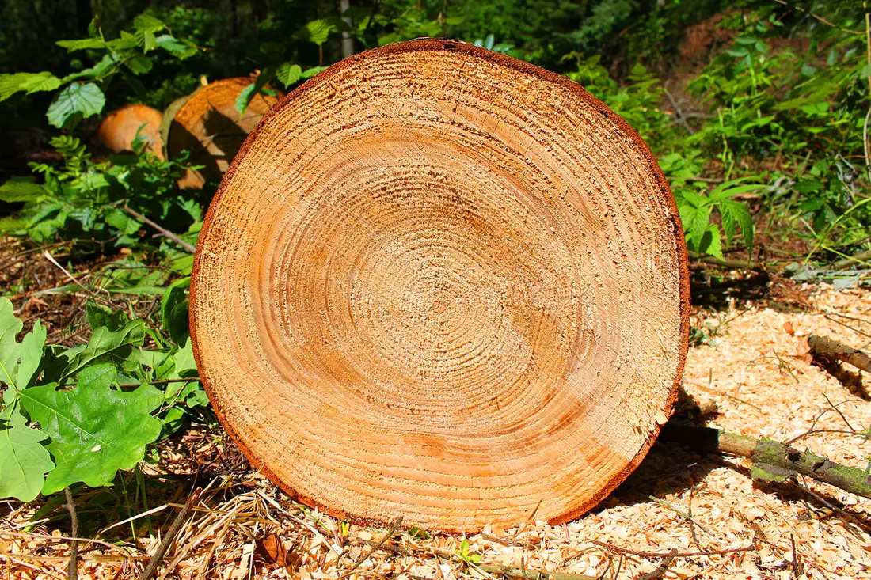  Bonus task  Create and name your own shape. It could be as crazy as you like! Will it have:  - Corners  - Edges  - Sides (straight or curved)  - Maybe it will be 3D? | Learning intention: With help (sibling or friend)  I can problem solve and predict the shape of shadows  Use a torch or other light source to create shadows on a whiteboard or wall. Look at the different shapes made by everyday 3D objects. Can you predict the shapes of the shadows?  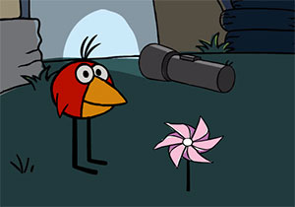  If you have puzzles, complete them and look at the different shapes. (I or A)  Create your own puzzle for a family member to solve. Draw a shape picture and cut it up. Get your family to solve it.  Bonus task  Find different places to count. Can you count how long it will take someone to:  - Eat a piece of toast?  - Dance to a song?  - Throw a ball 10 times and catch it in the air? | Learning intention: By yourself  I can make a shape pattern.  Be creative with what you use e.g. lego, books, placemats etc. Send photos to your teacher.  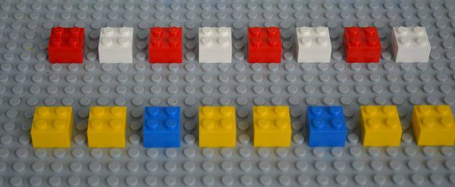  Bonus task  Create a shape song and send it to your teacher. Listen to Miss Rayner’s video for a funky tune.  https://drive.google.com/file/d/1EJh_ThVFu--HPW0IMaLxiD8E0Ph3uuwY/view?usp=sharing  Happy triangle to you, happy triangle to you, happy three sided triangle, happy three sided shape to you! | Learning intention: With help adult  I can use a number of different ways to problem solve  Please note this is an open ended task and there is more than one way to solve this problem. I wonder how many different ways you can think of?  If you could tile your bathroom what shapes would you use or not use? Watch Miss D’s video.  https://drive.google.com/file/d/1ZJwoYr5ucKtT2ZRb-MsGTKtjLKGeDfr1/view?usp=sharing

Inquiry Epraise activities

Lifestyle | Keep a track of the trees and their changing autumnal colours (can you draw this over a week, to see the changes and the leaves dropping. As a home helper can you rake the leaves up? | Keep a daily journal of your favourite home learning activity.
The Arts | Rock Art  The Ngunawal people created artwork on rocks. Find a rock or rocks and create an artwork with it.  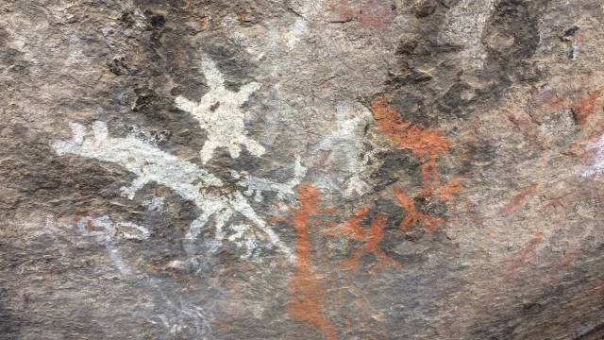 | Sock Puppets  Using an old pair of socks make some puppet characters or animals and put on a show for your family!  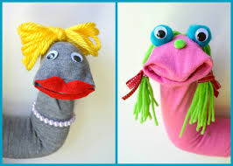
Living Things | What are your wonderings about Kangaroos in Canberra?  What do kangaroos need to survive in Canberra?  Write these down and send them to your teacher. | Watch a video from David Attenborough. If David came to Canberra where would you want him to explore?  https://www.youtube.com/watch?v=3EvV7VZSE_c
Movement and Health | Skip it, obstacle course or bike ride. Choose an outdoor activity.  Skipping time. Can you spend some time outside skipping?  Obstacle course - create this in your lounge room or outside. I wonder how creative you can be?  Bike ride - do you have a favourite bike riding route? Take some photos on your bike ride of all the living things. | Indigenous Inspired Movement  Leading on from our inquiry area (kangaroos) please watch the clip below.  https://www.youtube.com/watch?v=_b-vI3Nf50g  Can you follow/create movements of a kangaroo to the sound of the music. Send a video to your classroom teacher.
Fine Motor | Hole punch time  Find some interesting leaves outside and, using a hole punch, make confetti. | Build a Environment  Build an environment for a kangaroo from materials at your house.  Use lego, cardboard, sticks, anything you can find. Send through a photo to your classroom teacher. I wonder what things your Kangaroo would need to survive?

