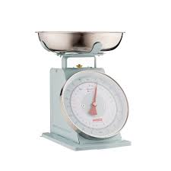
Measurement - Lesson 3
I can measure, order and compare objects using familiar metric units of capacity and use scaled instruments to measure and compare capacities.
Name:

Parents and carers please follow the yellow highlighted sections to support your child

Do this | Respond here
Check In

Watch;

Do:
What is mass?

Mass is a measurement of how much matter is in an object, person or substance. It is usually measured in grams or kilograms which is abbreviated as g or kg

Practice:

Check out

