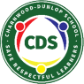
Charnwood-Dunlop School Home Learning
Reading is an essential skill required in all areas of learning.
Please continue to read with, or encourage your child to read, every day.

Week 1 - Term 2

Dear Families,

Welcome to Term 2. We hope that you have had a restful break. Attached is the learning for Week 1 and a list of websites that link to this week's learning that support student engagement during home learning.

The tasks have been compiled with our class’ prior learning in mind and will give children an opportunity to consolidate and extend their understanding. In addition to these learning experiences, we encourage the children to undertake fine motor activities such as cutting and using playdough which is necessary for writing. Reading should be undertaken everyday. Books should be explored and discussed to enable the children to make connections with the text. The weekly words can be found in print, made out of resources and written. Children are encouraged to complete tasks in their scrapbook to enable them to track their progress and celebrate their success as learners.

You may like to schedule your child’s day following their regular time table for example:
- 20-30 minutes of reading
- 20-30 minutes of writing
- 20-30 minutes maths tasks
- 20-30 minutes of physical movement
- Encourage creative at home tasks

Please don’t hesitate to contact us and we will get back to you as soon as we can.
Eliza.Savage@ed.act.edu.au
Gayle.Dyer@ed.act.edu.au
Helen.Hardy@ed.act.edu.au
Annie.Wild@ed.act.edu.au

Have fun!

The Kindergarten Team

Kindergarten Home Learning Grid Week 1

Navigating the grid:
- The shaded areas in the first line are suggested daily activities. These can be incorporated into your daily routine.
- The unshaded areas can be chosen according to interest, with the exception of the PBL choice. Please remember to keep the activities short (less than 30 minutes). If it is becoming stressful, then stop, take a break and come back to the task when everyone is feeling refreshed.
- Balance academic tasks and life skills.
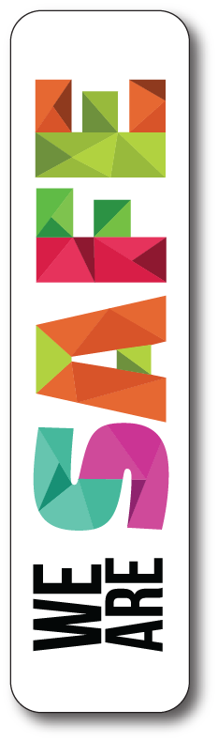
- We wash our hands with soap frequently  - We follow instructions | - We use kind words  - We put our things way | - We try our best  - We ask questions to find out something new

English | Reading strategy  Self to text connection  Has something similar happened to you?  How can you relate to the text?  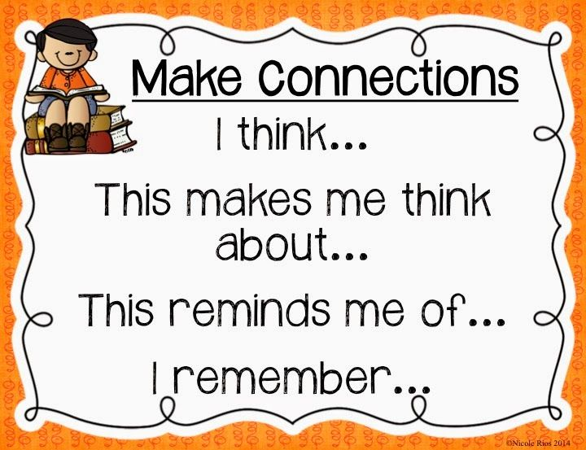 | Phonics in context  Letter sound of the week  /m/  Phonics experience: make muffins, a milkshake or mash potatoes  Look at your favourite story book. How many words beginning with ‘m’ can you find? Copy them into your workbook.  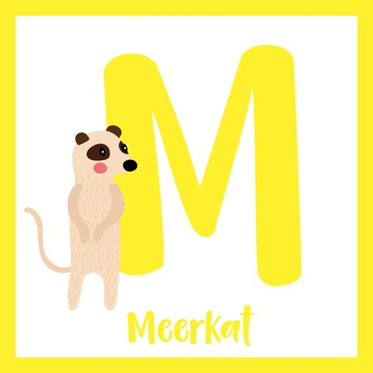 | Frequent words  Look in your picture books at home. Can you find these words?  am, and, be, in, is, it, of, the, to, mum  Make your own individual letters of the alphabet - use cut up pieces of paper, bottle top lids with letters written in permanent marker, stones with letters written on. Try making these words using your letters.  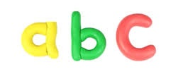 | Write a letter of happiness!  Write a letter to your favourite animal at Symbio Wildlife Park and they’ll write back!  https://symbiozoo.com.au/letter-of-happiness/  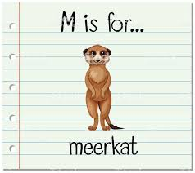
Maths | Numbers 1 - 10  Make numeral cards using recycled cereal boxes - cut up the boxes to make small cards - write a number (numbers 1 - 10) on each card.  Watch the Seesaw video of the teachers demonstrating this.  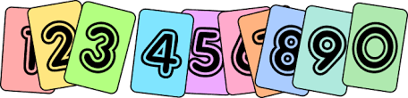 | Numbers 1 - 10  Seesaw video  Ordering numbers to 10, focusing on numbers before and after a given number.  Jumping game  One person calls out a number from 1 -10. Jump up and down that many times.  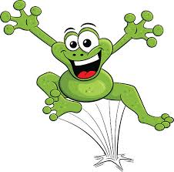 | Numbers 1 - 10  Seesaw activity:  Model the activity to show selecting a card, then asking which number would become before and after.  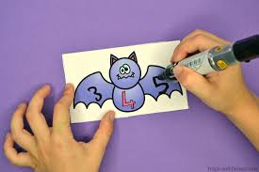 | Numbers 1 - 10  Using a deck of cards, play number snap.  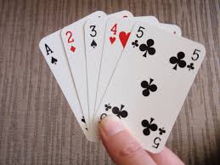
STEAM | Sustainability  Box construction  Start collecting used boxes (cereal packets etc) and design your own creation. Build a shelter for your favourite toy. | Force and Motion  Tell a family member about 5 things you can push and/or pull. Watch the song to help you remember.  https://www.youtube.com/watch?v=E-SnC_WKsCg | What is in my room?  Draw a picture of your room and label it with everything you can push and/or pull. Take a photo and send it to us via Seesaw. | You can move it!  Create an object that can move using items from around your home. What forces are being applied? Take a photo/video and send it to us via Seesaw.
Inquiry | What do I wear today?  Make a temperature chart. View the teacher video on Seesaw to find out what to do. | What do I wear today?  Look at your temperature gauge. Which clothes would be appropriate to wear today? | Weather Diary  What is the temperature today?  What clothes did you wear?  What changes can you see in the environment? | Environmental Awareness  Have you noticed any changes in the environment? Do the trees look the same as in summer? Has your family needed to put the heating on? What is happening to the weather?
Health, Community and & PE | Community  Make a card for your mum. Focus on using a full stop at the end of the sentence.  Remember to draw a picture.  What words can you write to describe your mum? | Healthy food  Watch the video:  https://www.youtube.com/watch?v=mMHVEFWNLMc  Cut out or draw pictures of healthy food from magazines and paste them into your work book. | PBL  Talk with your family about some new learning that you are proud of.  Create a short video to tell us about your learning. Send it to us via Seesaw. | Outdoor Play  Dig in the garden.  Walk around the block with your family.  Run laps around your yard- what is your person
Healthy food game ideas
The veggie guessing bag
Try this activity to increase children’s recognition and awareness of different vegetables.
Place some vegetables in a bag (e.g. pillow slip). Ask children to feel inside the bag and guess which vegetables are there.
Odd one out
Say a series of four words including three vegetables and one odd word, for example, “Carrot, potato, cat, onion”. Ask children to identify the odd word.
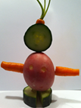
Make the game more challenging by using an odd word that is also a food, for example, “Celery, capsicum, carrot, yoghurt”. Ask the children why the odd word does not belong with the rest of the group.
Create a vegetable person
Create a ‘vegetable person’ using real vegetables or pictures of vegetables. Help children use toothpicks to make
their vegetable person stand up and be three dimensional. If using real vegetables, encourage children to eat their vegetable person for morning or afternoon tea.
Create a food alphabet
Create a visual food alphabet wall display. Children can cut out pictures of food and match these to a letter or draw their own impression of the food.

Please visit the websites below that can support learning

Jack Hartmann /m/
https://www.youtube.com/watch?v=WFMI-cV9sq8

Ordering numbers 1 - 10
https://www.youtube.com/watch?v=OXjz8vkL_QE

Days of the week
https://www.youtube.com/watch?v=mXMofxtDPUQ

Sustainability
https://www.youtube.com/watch?v=lieN18OTlME

Exercise and Rhyme
https://www.youtube.com/watch?v=cSPmGPIyykU

Art Hub
https://www.youtube.com/results?search_query=arthub

Create your own sight word bingo game
https://sightwords.com/sight-words/games/bingo/card-creator/

