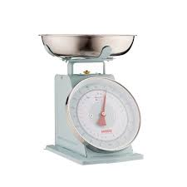
Measurement - Lesson 2
I can measure, order and compare objects using familiar metric units of mass and use scaled instruments to measure and compare masses.
Name:

Parents and carers please follow the yellow highlighted sections to support your child

Do this | Respond here
Check In
The answer is 180
Find five questions

Solve the following subtractions. Write the answers in the respond column.

36
- 13
679
- 343

486
- 263

338
- 212

2445
- 1234

Watch;

https://www.khanacademy.org/math/cc-fourth-grade-math/imp-measurement-and-data-2/imp-estimating-mass/v/metric-weight
.

Read:
What is mass?

Mass is a measurement of how much matter is in an object, person or substance. It is usually measured in grams or kilograms which is abbreviated as g or kg

Do:
https://www.studyladder.com.au/games/activity/measure-mass-using-scaled-instruments-21922?backUrl=/games/mathematics/au-year-four/mathematics-m

Check out

Make a list of 5 items that would measure in kilograms (kg).
Kitchen
bedroom

