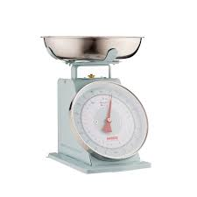Measurement - Lesson 1
I can measure, order and compare objects using familiar metric units of mass and use scaled instruments to measure and compare mass.
Name:

Parents and carers please follow the yellow highlighted sections to support your child

Do this | Respond here
Check In
How many 4s are in the following numbers...
4
24
36
Challenge:
2412

Read this problem and see what solutions you can draw.

From the numbers 9, 10, 11, list the odd number out.
You must give a reason.
Try to find as many different reasons as possible.

Watch;
https://www.youtube.com/watch?v=a3uy4H9kjB0

Do:

What is mass?

Mass is a measurement of how much matter is in an object, person or substance. It is usually measured in grams or kilograms which is abbreviated as g or kg.

Locate and list 5 - 10 objects in your house and their mass
Remember look for grams or kilograms

Practise:

https://www.studyladder.com.au/games/activity/estimate-mass-kilograms-34826?backUrl=/games/naplan/au-year-three/naplan-mathematics-outcome-based-revision-1

Check out

Explain
Heavy
Light
Weight
Heft

