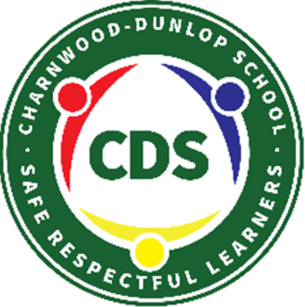
Preschool Home Learning Weeks 9 and 10

Dear Families,
We hope you are all healthy and as happy and relaxed as you can be during this time.
Our week 9 and 10 learning is presented as a grid. This is to provide you with a range of experiences that you and your child might like to try over the next couple of weeks. We have provided experiences to cover a five day fortnight to match the number of days your child would normally participate in their preschool education. Please understand these are a guide- all play and conversations are valued learning so if your child would rather continue with their own play and investigations, that is fine. Below the grid are some websites you may like to access for additional learning experiences for your child.
Your child’s teacher will be checking in with you via phone to support you and this is a great opportunity for you to have a chat, share how you and your child are going and ask any questions you may have.
We have started a closed Facebook group for our preschool families called CDS Preschool 2020 as a platform to communicate about home learning, particularly during the COVID-19 crisis. The aim of this group is to provide ideas and support each other. Please ensure all communication on the page is positive and relevant- we are all doing the best we can to navigate these new and unfamiliar times. We will respond to these posts when we can, during business hours only.
Please don’t hesitate to contact us and we will get back to you as soon as we can.
vicki.burke@ed.act.edu.au
ruth.everett@ed.act.edu.au
jaylene.hartgers@ed.act.edu.au
georgia.richardson@ed.act.edu.au
annie.wild@ed.act.edu.au (School Leader)

If you need to email outside of school business hours please send us an email at our school’s general address: info@charnwoodps.act.edu.au. We would love you and your children to send us updates on how you are going, what you have been doing and of course, how much you miss us.
Charnwood-Dunlop Preschool Home Learning

Read a book each day. You can read with someone, or listen to reading.  After reading, draw a picture of your favourite part or favourite character. | Keep active.  How many hops can you do on one leg?  Can you do star jumps?  How many jumps can you do? Can you do big jumps and little jumps?  Can you walk on tippy toes?  Try with shoes on and shoes off. What’s easier?  How many star jumps can you do in 1 minute? Maybe someone can time you and record your efforts. | Help at home.  You could tidy your room, set the table for a meal or help with the washing up. | Sing songs and dance.  You could teach your family some songs from preschool such as Five Cheeky Monkeys,  Five Little Ducks and the Hokey Pokey.
Write your first name 5 times. Which one turned out the best? Which one is the easiest to read?  Search your house! Can you find something that begins with each letter in your name? | Draw your family and make a frame from paddle pop sticks to display it in. | Find the numbers 0-10 around your home.  Go for a walk. Find and read the numbers on the houses and buildings! | Every time you wash hands remember to use soap and to dry your hands well.  Learn the handwashing song attached to this document to sing twice as you wash the front, the back and between your fingers.
Create PBL expectations for your home.  How can you be a  safe, respectful learner?  Draw a picture of doing these behaviours. | Follow the recipe to make some playdough. Look for the numbers on the measuring cup. Have a go at pouring and stirring.  Have fun rolling out snakes, making super flat pancakes and different sized balls. What else can you make? | Set up a shop and make mud pies or pretend drinks to sell. Your teddies and other toys could be your customers!  You might need to make some money and price tags for your shop. | Water play with cups, scoops and items that float and sink.  Label two buckets- one for items that float, and one for those that sink. Sort the items into each bucket.
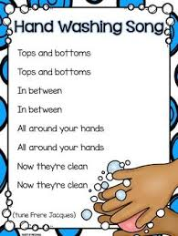
Online Resources for Preschool

ABC Education
https://education.abc.net.au/home#!/home
Little Yarns
https://www.abc.net.au/kidslisten/little-yarns
Funky nursery rhymes and dance
https://www.youtube.com/watch?v=29TR33moqUA
Justine Clarke
https://www.youtube.com/channel/UCaJvmm0IwfTpZz-xsABXw8Q
Zoo animals
9JI01thiHYIwww.zoo.org.au/animal-house/
Go Noodle
https://family.gonoodle.com/
ABC Count us In
https://www.enhancetv.com.au/video/count-us-in-counting/1677
Read alouds: Mem Fox
https://memfox.com/

