Charnwood-Dunlop School
Term 2 Week 2 Home Learning- LSU

Hi everyone ,welcome to week 2 of term 2. I was very impressed to see all the effort you are all putting in to complete your home learning grid and Seesaw activities. Together we will learn new things and consolidate some of our prior learning. Tracey and I have loved seeing all the videos and pictures that have been sent to us through seesaw or email. Keep up the fantastic work and remember to do something nice and be kind and respectful to the people that are helping you with your learning. Please make sure you log into Seesaw each morning before 11am and date all of your work in your work book as you complete the activities. Thank you to everyone’ for your support and flexibility at this time.

Navigating the grid:
- We recommend that as a family you set your own PBL (Positive Behaviours for Learning) expectations for your child’s home learning. This will assist you to avoid misunderstandings and to set expectations and routines.
- We have included below some PBL expectations that you may wish to use with your child throughout the week.
- Please remember to keep the activities short (approx 30 minutes). If it is becoming stressful, then stop, take a break and come back to the task when everyone is feeling refreshed.

English and Maths Grid:
- This term we have created a weekly timetable as your teachers will be uploading additional information and videos on seesaw to support your child’s learning. These uploads will support the day’s learning experiences that are displayed in the grid below.
- Starting this week, teachers have added a bonus section underneath each learning task for English and Maths. This will allow for you to continue supporting your child if they require additional work. These tasks are optional.
- Your child may choose to complete tasks in their work books or online. If in a workbook you may choose to take a picture and post it online to seesaw or send your teacher an email.
Inquiry Epraise Activities:
- Your child will also be rewarded an Epraise point for being an ‘Independent Learner’.
- You may wish to complete 1-2 activities from the grid for each day. There is no expectation that your child has to complete all activities throughout the week.
- Balance academic tasks, connections at home and life skills.

- We wash our hands with soap frequently  - We follow instructions | - We use kind words  - We put our things way | - We try our best  - We ask questions to find out something new

If you have any questions about your child’s learning or want to provide us with updates please email me.

dawn.schwalm@ed.act.edu.au

Daily Activities - Week 2
 | Monday | Tuesday | Wednesday | Thursday | Friday
English  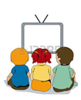  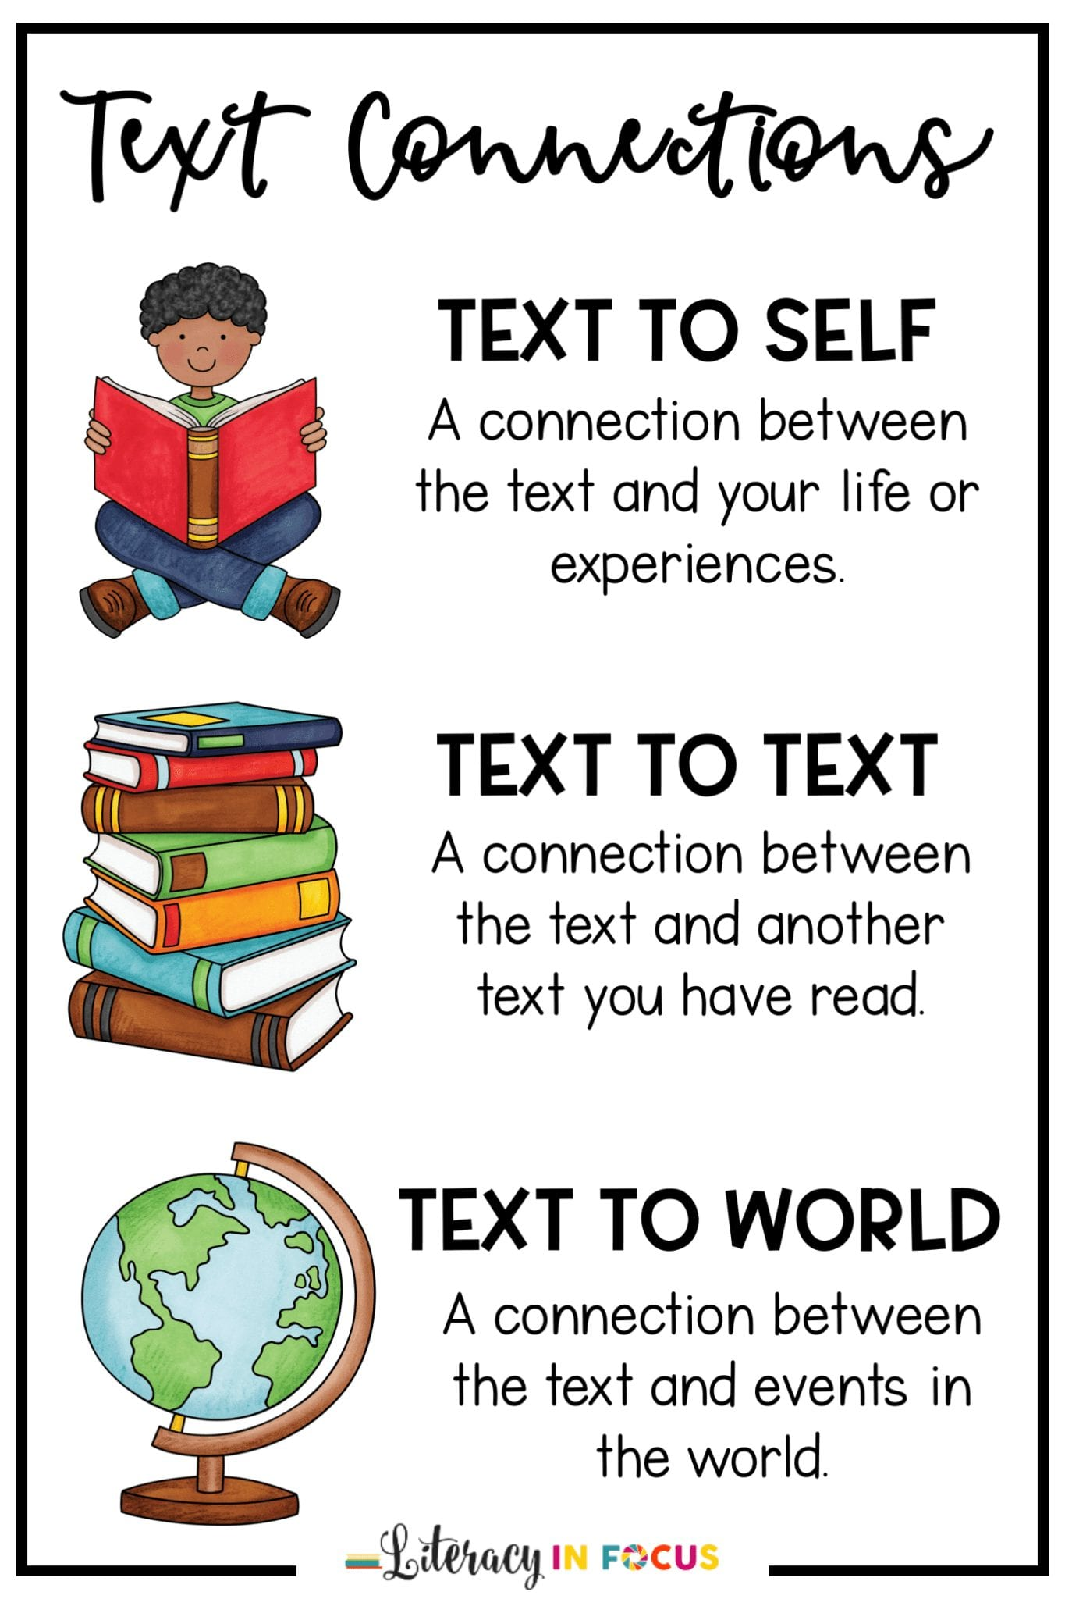 | Reading  Watch morning Hot read on Seesaw and talk about the book to a family member.  Writing  Draw two favourite characters in the book and write a description about why you like them or label.  Phonics in context  Blend: bl  https://drive.google.com/open?id=1vxG55Nmbxa_1c_jJu8yHS4p8NFJMqSga  ‘bl’ Hunt  In your writing book, write all the words you can find that have ‘bl’ in them. (maybe in a book or calendar or food packets) | Reading  Watch morning Hot read on Seesaw and talk about the book to a family member.  Writing  Draw a scene or place in the book and write or verbally describe it.  Phonics in context  Write simple sentences using as many /pl/ words as you can.  Example-  Blink with two blue eyes.  Black is better than blue.  Draw pictures to match your sentences. Cut them up and make a matching game. | Reading  Read a familiar story and send it to us-you can act it out.  Writing  High frequency words  Complete the handwriting sheet with this week high frequency words.  I- of- you- it and in  Write sentences with at least one of the words in each. Challenge yourself and see if you can put 2 or more words in each sentence.  Example:  I like you.  I ate all of it.  Write in your work book. | Reading  Watch morning hot reads on Seesaw and complete the quiz.  Writing  Write a funny /bl/ story in your writing book. Check out Miss Rayner’s story below.  https://drive.google.com/open?id=1FBZ-ZZbVg2g0o-XOo1fsIelmEah9DPUq  Bonus Activity  Word Jumble of the Day.  Can you find the bonus word? | Reading  Find a special place to read(maybe in bed, make a tent or under the dining table) Send us a picture or video  WritingWatch Ms Archie’s read aloud of My Two Blankets.  https://drive.google.com/open?id=1N8pecs6Ph7tBNs4rbRcg6FiunXQEzvrd  Draw and design your own blanket. Include pictures or items that you like or find comforting.  Will it have patterns? Colours? What else?
Maths  Focus- Shapes  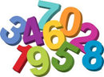  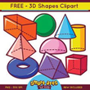 | With an adult or sibling  watch  https://www.youtube.com/watch?v=beTDz9HSNOM  Draw and label as many 2D shapes as you can. Write some clues for them in your work book. For example,  I have four sides that are all the same, I also look like a sandwich? What shape am I? | Code breaker  Write your name using only 2D shapes. Using these shapes make your own alphabet and write a secret message for someone in your house to work out.  Watch Miss Rayners video.  https://drive.google.com/file/d/1rsQDaYcicxZe9hr0ZcpqqIMxrc-qCaGu/view?usp=sharing | Mr Squiggle.  Using a piece of paper-  Draw and cut out  7 triangles  6 squares  2 circles  3 rectangles  What picture can you make?  Set your family the same challenge  Paste them into your work book and label your work | With an adult or sibling: you will need:  A piece of paper.  Sit back to back to create an image with a partner by telling them the shapes and where to draw them. You are not allowed to look at each other's drawings until the end.  See video with Miss D and Miss R.  https://drive.google.com/open?id=1Mq2jPqHDyWnbeodj86RaOdyiyssPm78u | With a sibling or adult:  Celebrity Shapes - What shape am I?  This game is like Celebrity Heads. Write down different shapes on a post it note or small piece of paper. PLace it on your forehead and ask questions to work out which shape you are.  Play the game with other members of your family.

Epraise Activities - Fortnightly
Lifestyle  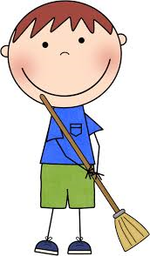 | Make your own coins and notes and set up a shop. Make some price tags and place them on some items in your home. You may wish to use some crafts you have created or grocery items or look at shop catalogues.  Play a game with your siblings or an adult where you are the shopkeeper and they are the customer. Reverse the roles. |  | Keep a track of the trees and their changing autumnal colours (can you draw this over a week or two, to see the changes and the leaves dropping… as a home helper can you rake the leaves up?  Collect some of the different colours and shapes around your home  Draw in your work book
The Arts  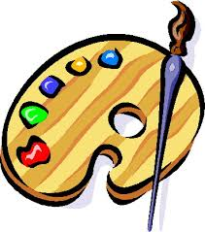 | Stick Drummer  Find two sticks that aren’t too big to be drumsticks.  Tap them on different things and notice the sounds different materials make.  Can you make a beat or pattern and teach it to someone?  Can you write down (notate) your beat or pattern? |  | BLUE Dancer  https://youtu.be/AFIqSaZM2D0  Dance along to the BL Song.
Inquiry Rainforest | Viewing and listening  10 daintree animals that are found nowhere else in the world. Watch the video, pick one animal, google the facts then write a report answering these questions. Write in your workbook.  What is the name of your animal?  Where does it make its home?  Describe your animal.  What do they eat?  Find out an interesting fact.  https://blog.queensland.com/2015/06/17/daintree-rainforest-animals/ |  | Research an animal from the Daintree rainforest. Watch one of the links below.  Make a list in your workbook of things that your animal needs to survive ( shelter, what kind of food, what do they drink, what do they need to be warm)  Remember to write your answers in your work book.  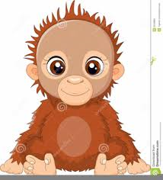
Movement and Health  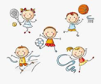 | Shooting hoops  Using a pair of socks and a laundry basket, how far can you throw the socks and land them in the basket?  Challenge - How many times can you land them in the basket in 1 minute? |  | Animal circuit  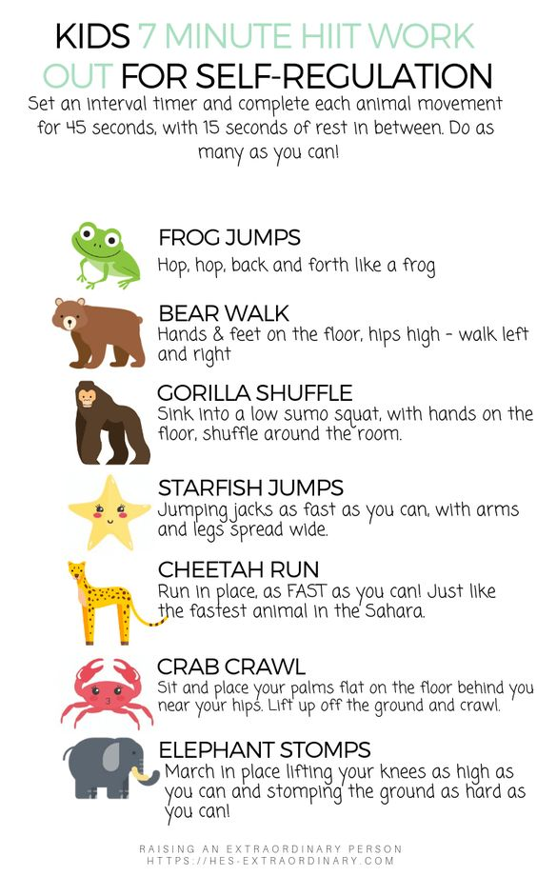
Fine Motor  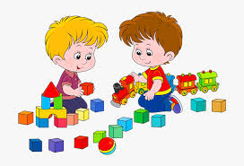 | Build a Structure using your hands and fingers, perhaps where a rainforest animal can live. Build a structure from materials at your house.  For example, use lego, cardboard, sticks, straws  Take a picture and send it to us on Seesaw.

Inquiry Online Resources

Living Things Song: https://www.youtube.com/watch?v=tzN299RpJHA
Living Things Video: https://www.youtube.com/watch?v=Gy60BqCnTG4
Living vs non-living video & activities: https://www.generationgenius.com/videolessons/living-vs-non-living-things-video-for-kids/#lesson_materials
Follow-Along Drawing/Craft Channel: https://www.youtube.com/user/ArtforKidsHub
Playschool Story Time (read alouds) https://iview.abc.net.au/collection/2392
Story Dramatisations (30 minutes approx) https://iview.abc.net.au/collection/407
Andy’s Safari Adventure (14 minutes each about animals!) https://iview.abc.net.au/show/andy-s-safari-adventures
Kid Friendly Info About COVID-19 https://www.abc.net.au/btn/newsbreak/btn-newsbreak-20200323/12082020
Aboriginal Star Mapping https://www.abc.net.au/btn/classroom/aboriginal-astronomy/10523908
Aborignal Place Names: https://www.abc.net.au/btn/classroom/indigenous-place-names/11164046

Maths Resources

Maths - Place Value Party (choose how big numbers will be first) https://www.mathplayground.com/place_value_party.html
Maths - Place Value Basketball (choose how big numbers will be first) https://www.topmarks.co.uk/learning-to-count/place-value-basketball
Oxford Owl Maths Videos (watch the early maths skills ones) https://www.youtube.com/playlist?list=PLB5TN0ac12P_p1yZu7bieuGfK8X5pptza
Money Games (choose Australian coins and the task first) https://www.topmarks.co.uk/money/coins-game
2D Shapes
https://www.youtube.com/watch?v=beTDz9HSNOM

10 daintree animals that are found nowhere else in the world.
https://blog.queensland.com/2015/06/17/daintree-rainforest-animals/

BLUE Dancer
https://youtu.be/AFIqSaZM2D0

