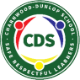
Charnwood-Dunlop School
5/6 Term 2 Week 2 Home Learning

This term, 5/6 will continue learning about states of matter and will finish up with their natural disasters inquiry unit. We will then move into our Civics and Citizenship inquiry unit for the remainder of term 2.
In the timetable below there are tasks related to these topics along with literacy and math lessons to revise and extend on concepts learnt at school.

Navigating the timetable:
- We recommend that as a family you set your own PBL (positive behaviours for learning) expectations for your child’s home learning. This will assist you to avoid misunderstandings and to set expectations and routines.
- We have included below some PBL expectations that you may wish to use with your child throughout the week.
- Please remember to keep the activities short (approx 30 minutes). If it is becoming stressful, then stop, take a break and come back to the task when everyone is feeling refreshed.
- The timetable is a suggested schedule only. This can be adapted to meet the needs of your family, however some lessons may not be available until the set day. There is no expectation that your child has to complete all activities throughout the week, however the more your child participates the more they will get out of online learning.
- Try to balance academic tasks and life skills.
- Your mental and physical wellbeing are just as important as your learning as we navigate these uncharted waters.
- The majority of the below tasks will be completed in google classroom. If you can not access this, you will be able to access some of these tasks/worksheets from the Charnwood-Dunlop School website under home learning.

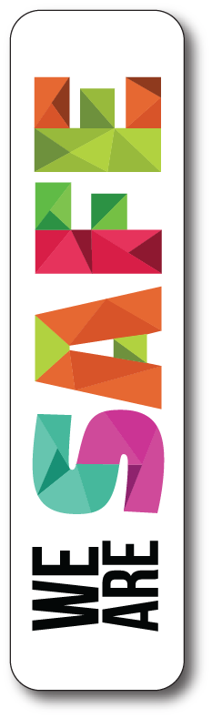  - We wash our hands with soap frequently  - We follow instructions  - We do not access content on the internet without parents or teachers permission | 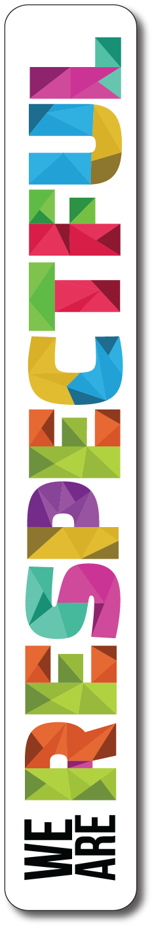  - We use kind words  - We put our things way  - We wait our turn when using google meets | 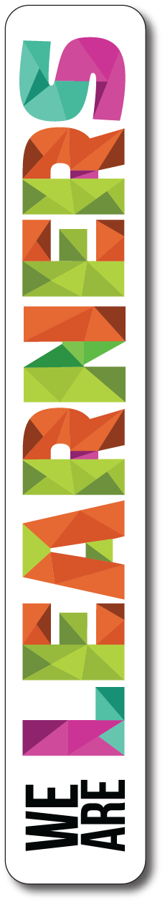  - We try our best  - We ask questions to find out something new  - We use our chromes appropriately

If you have any questions about your child’s learning or want to provide us with updates please email your child’s teacher.

 | Monday | Tuesday | Wednesday | Thursday | Friday
Morning | Hot Reads | Hot Reads | Hot Reads | Hot Reads | Hot Writes
 | Audio book  Please refer to google classroom for instructions | Spelling and Grammar  Simple, compound and complex sentences | Persuasive Writing  Looking at letter writing | Audio book  Please refer to google classroom for instructions | National Geographic  Let’s take a look at the world around us  Australia  Africa  Asia  Once you have watched these short videos you will need to write a minimum of 5 facts down in your online literacy book for each continent. Make sure you use a heading and put enough details in your dot points for us to understand what you are writing about.
 | Spelling and Grammar  What is a clause? | SEL / PBL  See activity from Mrs Middleton in her google classrooms. If you haven’t joined yet, the Classroom code is  kextxrv | Spelling  Word of the Week Challenge | Persuasive writing  Lets convince Mr Lans
Take a break!!!
Middle | Daily fitness and Brain Buster Challenge  Take a look into your weekly challenge book for this week's fitness challenges and brain buster. Don’t forget to upload a photo into the answer section of you doing fitness and make sure to put your challenge answers in to earn epraise points and prizes!
 | Maths  Transformations - Symmetry | Release  See activity from your release teacher in their google classrooms | Maths  Transformations - Translations | Maths  Transformations - Reflections | Maths  Prodigy - Have some fun practising your skills
Take a break!!!
Afternoon | Inquiry  Work on finishing off your Natural Disasters assignment  Finishing off work  This is your chance to finish off any work you didn’t get done earlier today or last week. | Release  See activity from your release teacher in their google classrooms | Science  Revision of Solids, Liquids, & Gases | Inquiry  This is it… your absolute last chance to do your final touches on your Natural Disasters presentation. If you have done this then you owe yourself some down time! Grab a good book and a hot chocolate or a drink and put your feet up. | Finishing off work  This is your chance to work on any of the work posted throughout the week. Please make sure you are handing in work or uploading photos of your work to the folder on your drive shared with your teacher.

Additional learning
- Natural Disaster presentation
- Extra Hot Writes
- Extra Hot Reads
- Continue with Weekly Challenge

