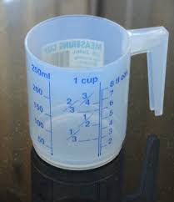
Measurement - Lesson 3
I can measure, order and compare objects using familiar metric units of capacity and use scaled instruments to measure and compare capacities.
Name:

Parents and carers please follow the yellow highlighted sections to support your child

Do this | Respond here
Check In

Doubling

Start at
10 and see how far you can double

Start at 6 … see if you can double to 10 plus places

Make you own doubling sequence and see if you can get to 4 digits

Problem- solving

From the numbers 14, 15, 16, list the odd number out. You must give a reason. Try to find as many different reasons and different answers as possible.

Watch;
https://www.khanacademy.org/math/cc-third-grade-math/imp-measurement-and-data/imp-volume/v/liter-intuition

Do:

Estimate how many cups make a litre?

Find a litre container and a cup measure. Use the cup and fill the container.
Did it match your estimate?

Practice:

Use the diagram and follow 1-5 to show the capacity from least to most

https://documentcloud.adobe.com/link/track?uri=urn:aaid:scds:US:0d483a9b-cd15-401d-9364-0ff7c44d30cd

Check out

Use this image and identify possible uses for measuring
