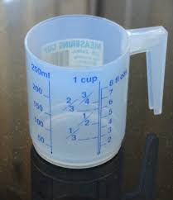
Measurement - Lesson 2
I can measure, order and compare objects using familiar metric units of capacity and use scaled instruments to measure and compare capacities.
Name:

Parents and carers please follow the yellow highlighted sections to support your child

Do this | Respond here
Check In
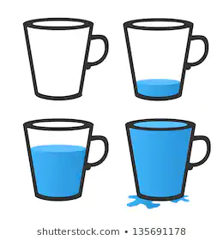
Describe each cup

Using the numbers 4, 5, 8, 6, 7, 9, write down the largest possible 4-digit number. Write down the smallest 4-digit number, again using the numbers at most once. What is the difference between these two 4-digit numbers?
Remember to show your working
Watch;
https://www.youtube.com/watch?v=TPFQd7ZjErU

Do this activity outside  Find 2 different sized saucepans and 1 cup measure  Fill each saucepan and record the number of cups for each saucepan  What did you find out?  What do you think would happen if you used a teaspoon? | Saucepan 1 Number of cups  Saucepan 2  What did you observe?
Check out

How can you show the capacity of a container?

