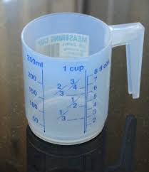
Measurement - Lesson 1
I can measure, order and compare objects using familiar metric units of capacity and use scaled instruments to measure and compare capacities.
Name:

Parents and carers please follow the yellow highlighted sections to support your child

Do this | Respond here
Check In
How many 2s are in the following numbers...
6
24
30
Challenge:
1502

Read this problem and see what solutions you can draw.

Ali is mad for motorbikes and limousines.
He knows that motorbikes have 2 wheels.
He also knows that limousines have 6 wheels.
During a lesson he looks out of the window and is amazed to see a number of motorbikes and limousines.
In total he counts 18 wheels.
How many motorbikes and limousines did Ali see?
Could you find more than one answer?

Watch;
https://www.youtube.com/watch?v=TPFQd7ZjErU

Do:  Locate and list 5 - 10 objects in your house and their capacity  Remember look for liquids  Find 2 different containers such as a cup and saucepan  Use a teaspoon and tally (count) the number of teaspoons  Does it change if you use a tablespoon? | Container Number of teaspoons
Check out

Explain
Empty
Full
Container
Same capacity

