Dear Families,

Welcome back to Term 2, and the continuation of our online journey. We hope you had a restful and enjoyable holiday.
We have put together another learning grid with suggestions of experiences for children to enjoy. These experiences are focused on play based learning, however parent/carer support may be needed to guide the learning of some experiences. Please find attached below a list of websites that will support children’s engagement with their home learning.
These experiences have been compiled with our class’ prior learning in mind and will give children an opportunity to consolidate and extend their understandings and develop skills for school readiness. From week 3, our home learning will focus on a shared inquiry question. More information will be provided at this time. This term also sees the beginning of the team using the Seesaw platform to share learning and communicate with families. If you are yet to return your permission note and would like to participate, there is still time for you to join us.
The school will continue to communicate with you regarding any updates, primarily via email. We will continue to make wellbeing calls to families and the 2020 CDS Preschool Facebook page is updated on a daily basis. Please don’t hesitate to contact us and we will get back to you as soon as we can.
vicki.burke@ed.act.edu.au
ruth.everett@ed.act.edu.au
jaylene.hartgers@ed.act.edu.au
georgia.richardson@ed.act.edu.au
annie.wild@ed.act.edu.au (School Leader)

Have fun!
The CDS Preschool Team

We all love books!  Choose a book that you like. Can name the colours you see in the pictures?  How many do you know?  Use some colours to draw a rainbow or another very colourful picture.  Hang up your creation for your family to enjoy. | Let’s get active  Go for a walk or ride a bike in the sunshine with your family.  Play catch with your family,  Play hide and seek  or kick a ball.  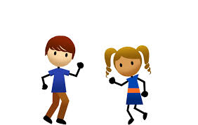 | What can you do to help at home?  Feed and walk your pets?  Clean and tidy your bedroom?  Dusting around the house?  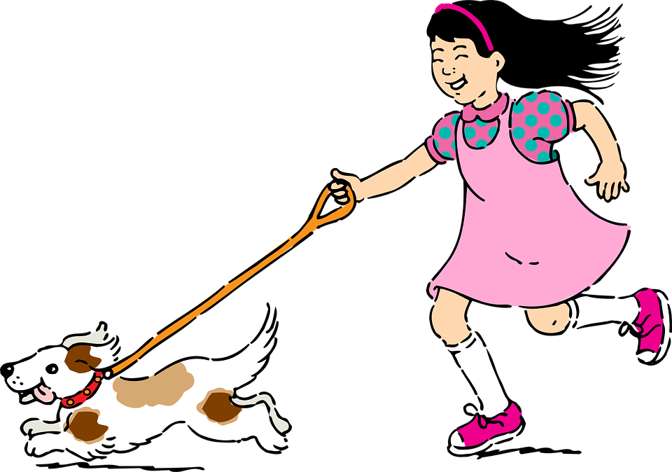 | Sing songs and dance  Justine Clark  Just Dance Kids  See the links below!  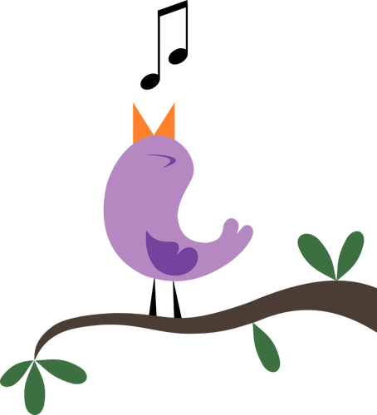
Learning our names  What could you use to make the letters in your name?  Take a photo to show your teachers on Seesaw or Facebook.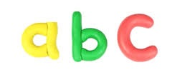 | Making music  See if you can make some of your own instruments.  Maybe use a saucepan and a wooden spoon, rice in an empty Milo tin, tap two utensils together.  Can you tap to the beat of some music with your instrument or play a tune and sing along? | Go for a nature walk  Collect some sticks and stones and make a pattern from them. How many different patterns can you make?  What else can you make  using the sticks and stones eg. a tower of stones, sticks lined up according to height. | Scavenger hunt  Go on a Scavenger hunt!  See below for an indoor and an outdoor hunt.
Be creative and build  Can you build a cubby house inside using sheets and other items?  Can you build a house with Lego or blocks? You could even build a tower from empty cardboard boxes  We would love to see your creations. | School is great  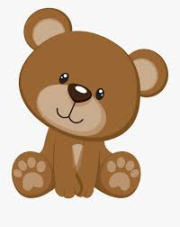  Play schools with some soft toys. You might like to read a book to your toys. Don’t forget to remind them to sit on their bottoms and be respectful learners. | Shape fun  Use your fingers to make shapes and letters. Can you make a diamond, triangle, circle, L and T? What else can you make?  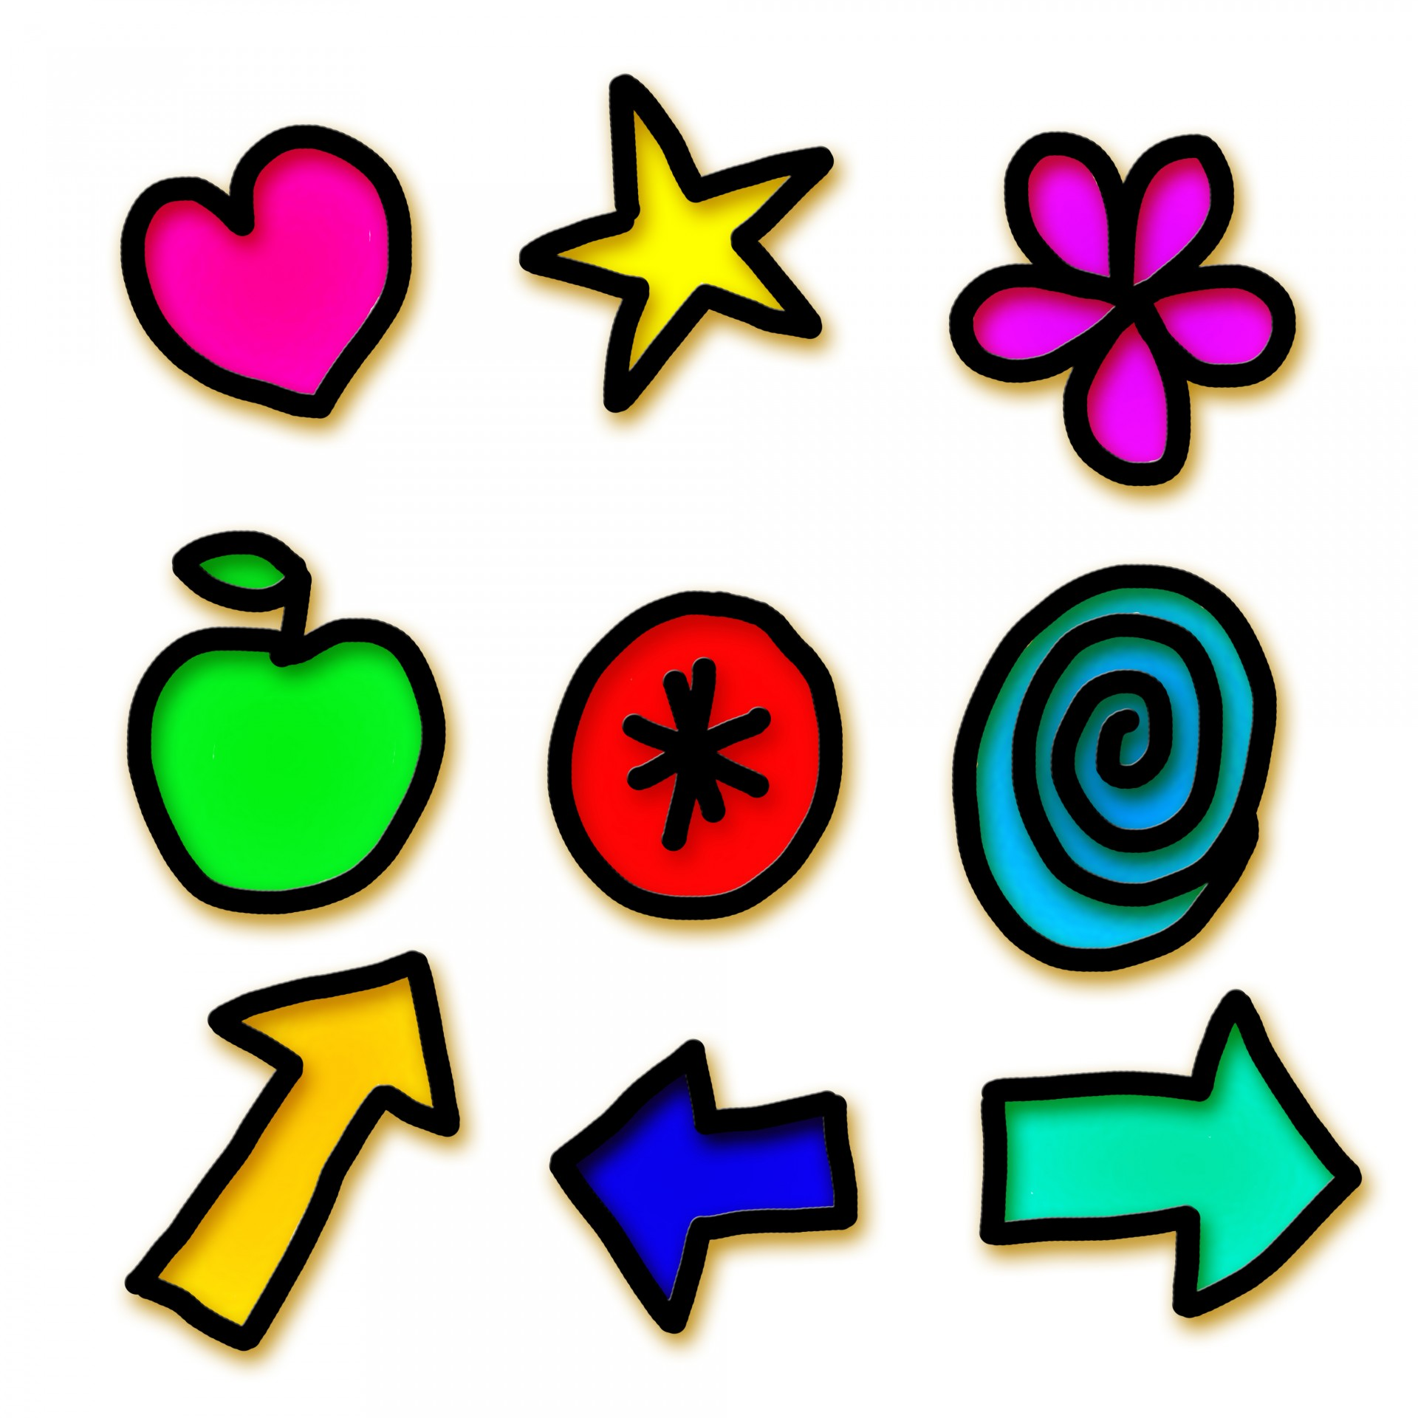 | Rest time  See if you can make a star pose and lie still. Take some deep breaths as you listen to some music.  Could you quietly lay outside?  What can you hear? What shapes are the clouds making today?
Indoor Scavenger Hunt
Collect each of the following items in a bag or a basket.
Make sure when you are done that you put everything back!

- Collect three round items from around the house
- A book about an animal
- An item smaller than your hand
- Find three items that are green
- Find something smooth
- Find two things that are rough
- Find 5 things that are square shaped
- Look for an item with numbers on it
- Look for something that has wheels
- A pair of matching socks
- A book with numbers in it
- Find your snuggliest stuffed toy
- A photo of someone you love
- An item you can see yourself in
- An item that makes you happy
- A toy that has 3 different colours on it
- Find something your favourite colour
- Find something that you can use to make a gift for someone

Outdoor Scavenger Hunt
Collect each of the following items in a bag or a basket.
Make sure when you are done you put back the things you can.

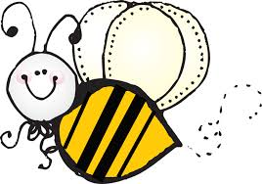
- 5 leaves that look different
- A stick that is longer than your hand
- A rock with spots on it
- A flower
- A flat rock
- 10 blades of grass
- Something you love to play with
- Something that is brown
- Something that is heavy
- Something that is very light
- Something that needs the sun to live
- An item that is smaller than your thumb
- Something that starts with ‘M’
- Something that smells good
- Can you find three different insects (just look, don’t touch)
Online Resources for Preschool
ABC Education
https://education.abc.net.au/home#!/home
Little Yarns
https://www.abc.net.au/kidslisten/little-yarns
Funky nursery rhymes and dance
https://www.youtube.com/watch?v=29TR33moqUA
Justine Clarke
https://www.youtube.com/channel/UCaJvmm0IwfTpZz-xsABXw8Q
Zoo animals
9JI01thiHYIwww.zoo.org.au/animal-house/
Go Noodle
https://family.gonoodle.com/
ABC Count us In
https://www.enhancetv.com.au/video/count-us-in-counting/1677
Read alouds: Mem Fox
https://memfox.com/
ABC iView - Playschool Story time
https://iview.abc.net.au/show/play-school-story-time

