Term 1 | Mind | Body | Answers / Photos
Week 9 | Click on the link, follow the clues and see if you can find the answer!  What does it equal? | Get your fit on!!  PE with Joe  Fitness 101. This challenge needs to be done twice this week. Do each activity x10 or for 30 seconds  Fitness Challenge
Week 10 | 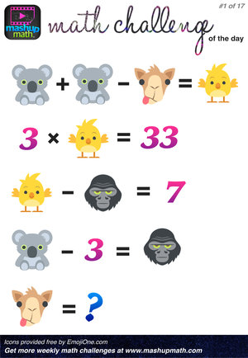 | Balloon ball: Try to keep your balloon off the ground for 5 minutes while keeping it constantly moving in the air. Try and beat your time throughout the week.  Get your fit on!  PE with Joe | Koala =  Giraffe =  Chicken =  Gorilla =  Balloon ball:  Attempt 1 -  Attempt 2 -  Attempt 3 -

