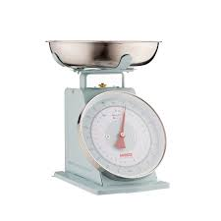
Measurement - Lesson 3
I can measure, order and compare objects using familiar metric units of capacity and use scaled instruments to measure and compare capacities.
Name:

Parents and carers please follow the yellow highlighted sections to support your child

Do this | Respond here
Check In:

What shape am I?
Write 5 short questions and see if I can guess your shape

Solve:
337 + 456 =

Write your own addition algorithm

Watch;

https://www.youtube.com/watch?v=6h0G-7WxSDk

Do:

Write 5 different ways to make a kilogram

Find 5 things that weigh more than 1 kg

What is the total weight of the following

50g 10g 5g 5g 5g 5g
10g 50g 50g
10g 20g 50g 50g 50g

Estimate the weight of an apple
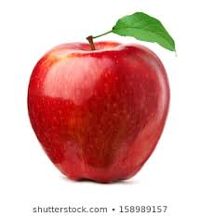

Check out
Explain What is mass?

