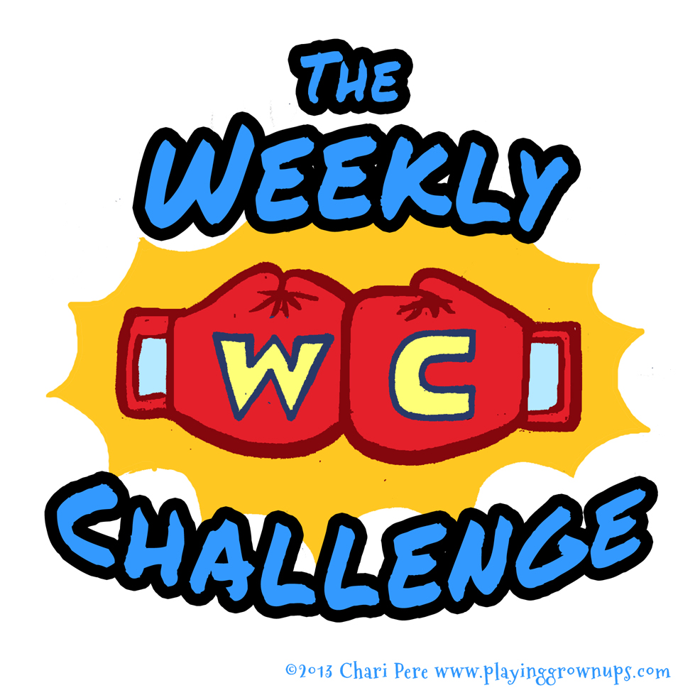

Each week a new mind and body challenge will be uploaded to google classroom. You will use this book to write your answers, show any working out and let us know how you went with your fitness and PE for the week (upload a photo of you doing your PE or fitness if you want to).
In the table below there are instructions and links to follow. There will be 1 mind challenge and 2-3 fitness challenges for the week.
Each student who gives it ago will earn epraise points to be spent when we are back at school. All challenge takers will also go into the draw to win weekly prizes! The more you participate the higher your chances.

ARE YOU READY TO TAKE THE CHALLENGE?

Term 1 | Mind | Body | Answers / Photos
Week 9 | Click on the link, follow the clues and see if you can find the answer!  What does it equal? | Get your fit on!!  PE with Joe  Fitness 101. This challenge needs to be done twice this week.  Fitness Challenge
Week 10

