3/4 Work Grid
This is a weekly schedule for learning...

Reading  Hot Reads  30 minutes every day | Retell what you read  Remember to include  Author and title | Interesting words  Make a list of interesting word from your book | Review  Write a book review on your book  Whose the best character?  Where is your story set?  What happens in the story? | Recommend  Is this a good book to read?  Who should read it?  Year 2 or Year 5  What makes it a good book?
Writing  WHAT IS A RECOUNT?  A recount retells an experience or an event that happened in the past. The purpose of a recount can be to inform, entertain or to reflect and evaluate.  A recount can focus on a specific section of an event or retell the entire story. A recount should always be told in the order that things happened.  Recount a magical moment | Recount  The best day ever... | Recount  Diary of an imaginary creature | Recount  What was an exciting moment? | Recount  What was the best holiday ever?
Maths  Remember to check your google classroom for more activities….  These are fun open ended maths tasks  There are many different answers, be creative and come up with numerous possibilities  Make a large, light package. Make a small, heavy package.  What are some times when the digits on a digital clock make a pattern? | What is something you can do exactly 100 times in one minute?  How can you make up a sentence with more than five words but no more than 20 words? | Make your own timetable to show a new student what happens in a school week.  Choose a number between 5 and 20. Write all the subtractions. For example 11, you can write 11-5=6 15-11=4  . | I read a book in 15 minutes. What book might I have read?  Draw a plan or map of the outside of your house | I went on holidays and made a snowman. What month of the year might it have been?  Create a symmetrical pattern with colours and shapes
 | Bound for Botany Bay  Write a description of a convict hulk.  Use the image to inspire you. Look carefully at the details in the picture.  Remember to use a topic sentence |  | Bound for Botany Bay  Read the following information on the Hulks in Google Classroom  Describe what it was like to live on a prison hulk.
Art  Sketch your bedroom  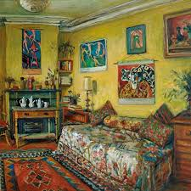  Margaret Olley  Vincent Van Gogh  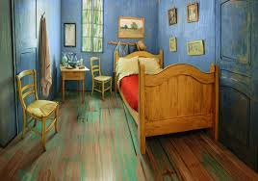 |  | Art  Sketch yourself  look in the mirror  Add a hat  …  Margaret Olley  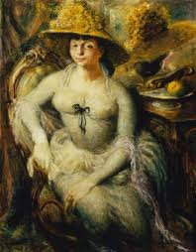  Vincent Van Gogh  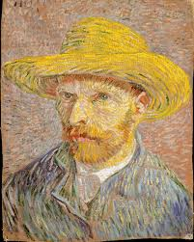 |  | Art  Sketch your favourite animal  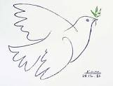  Pablo Picasso  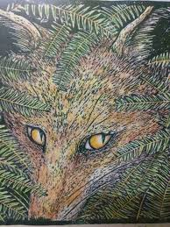  Narelle Oliver

